Compte rendu WRC23 (extraits de l’acte final)

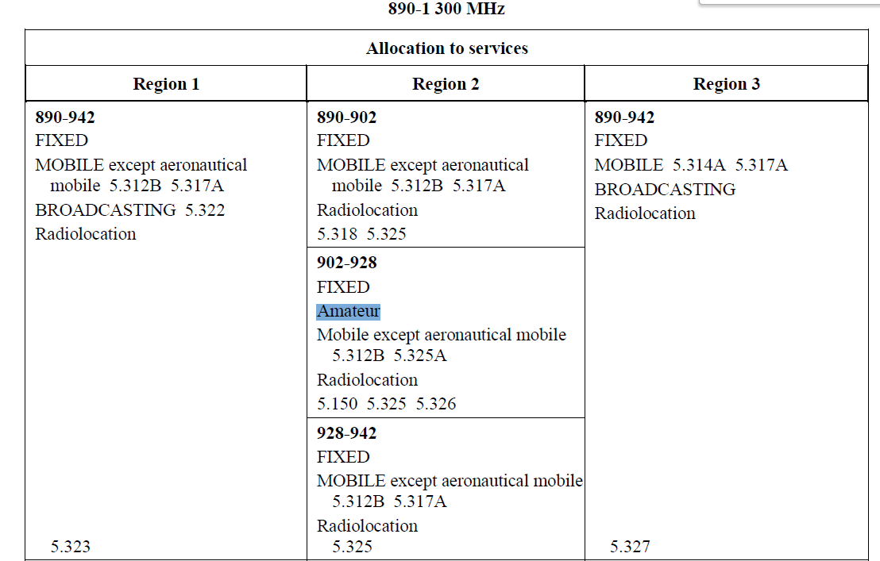

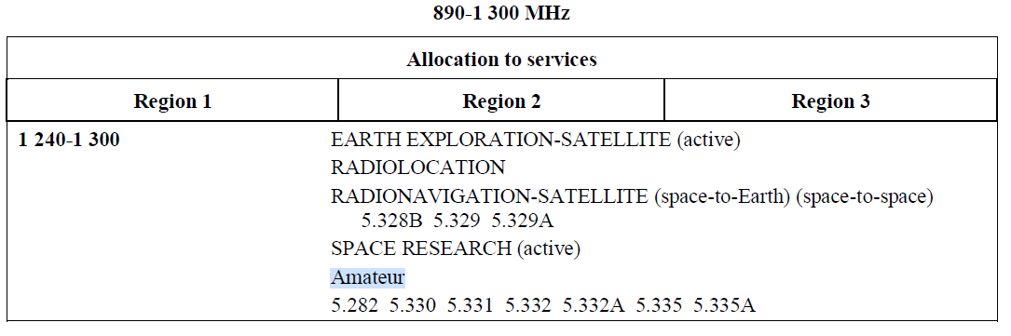
5.330 Additional allocation: in Angola, Saudi Arabia, Bahrain, Bangladesh, Cameroon, China, Djibouti, Egypt,
the United Arab Emirates, Eritrea, Ethiopia, Guyana, India, Indonesia, Iran (Islamic Republic of), Iraq, Israel, Japan,
Jordan, Kuwait, Nepal, Oman, Pakistan, Palestine*, the Philippines, Qatar, the Syrian Arab Republic, Somalia, Sudan,
South Sudan, Chad, Togo and Yemen, the frequency band 1 215-1 300 MHz is also allocated to the fixed and mobile
services on a primary basis. (WRC-23)
5.331 Additional allocation: in Algeria, Germany, Saudi Arabia, Australia, Austria, Bahrain, Belarus, Belgium,
Benin, Bosnia and Herzegovina, Brazil, Burkina Faso, Burundi, Cameroon, China, Korea (Rep. of), Croatia, Denmark,
Djibouti, Egypt, the United Arab Emirates, Estonia, the Russian Federation, Finland, France, Ghana, Greece, Guinea,
Equatorial Guinea, Hungary, India, Indonesia, Iran (Islamic Republic of), Iraq, Ireland, Israel, Jordan, Kenya, Kuwait,
Lesotho, Latvia, Lebanon, Liechtenstein, Lithuania, Luxembourg, North Macedonia, Madagascar, Mali, Mauritania,
Montenegro, Nigeria, Norway, Oman, Pakistan, Palestine*, the Kingdom of the Netherlands, Poland, Portugal, Qatar, the
Syrian Arab Republic, Türkiye, Dem. People’s Rep. of Korea, Slovakia, the United Kingdom, Serbia, Slovenia, Somalia,
Sudan, South Sudan, Sri Lanka, South Africa, Sweden, Switzerland, Thailand, Togo, Venezuela and Viet Nam, the
frequency band 1 215-1 300 MHz is also allocated to the radionavigation service on a primary basis. In Canada and the
United States, the frequency band 1 240-1 300 MHz is also allocated to the radionavigation service, and use of the
radionavigation service shall be limited to the aeronautical radionavigation service. (WRC-23)
5.332A Administrations authorizing operation of the amateur and amateur-satellite services in the frequency band
1 240-1 300 MHz, or portions thereof, shall ensure that the amateur and amateur-satellite services do not cause harmful
interference to radionavigation-satellite service (space-to-Earth) receivers in accordance with No. 5.29 (see the most
recent version of Recommendation ITU-R M.2164). The authorizing administration, upon receipt of a report of harmful
interference caused by a station of the amateur or amateur-satellite services, shall take all necessary steps to rapidly
eliminate such interference. (WRC-23)
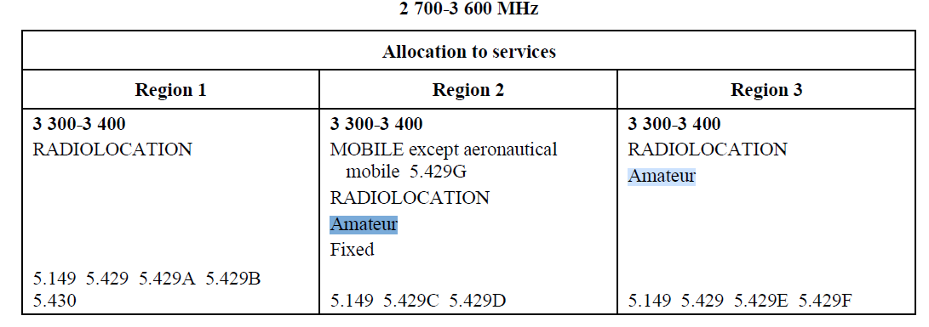
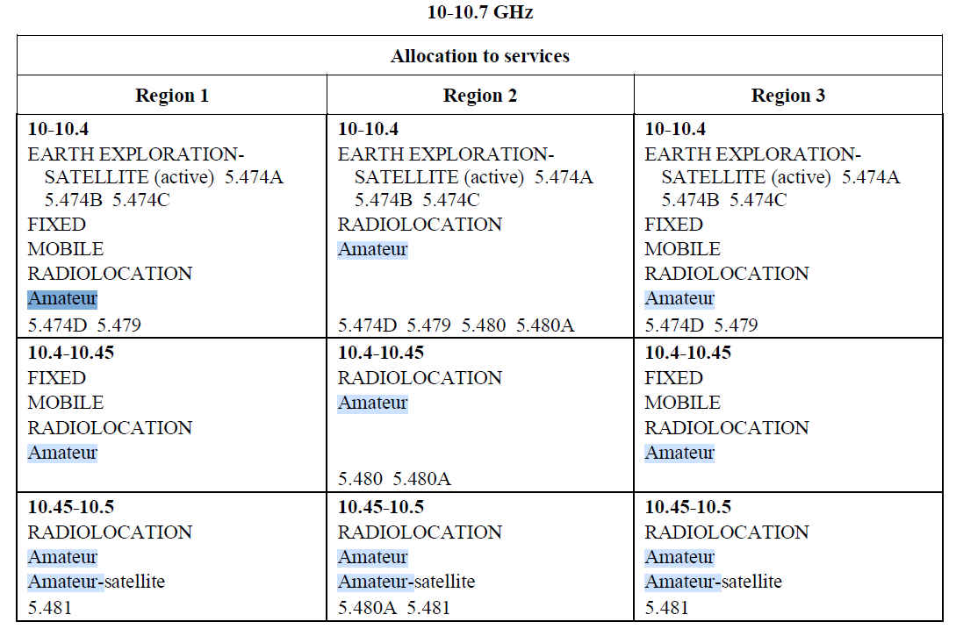
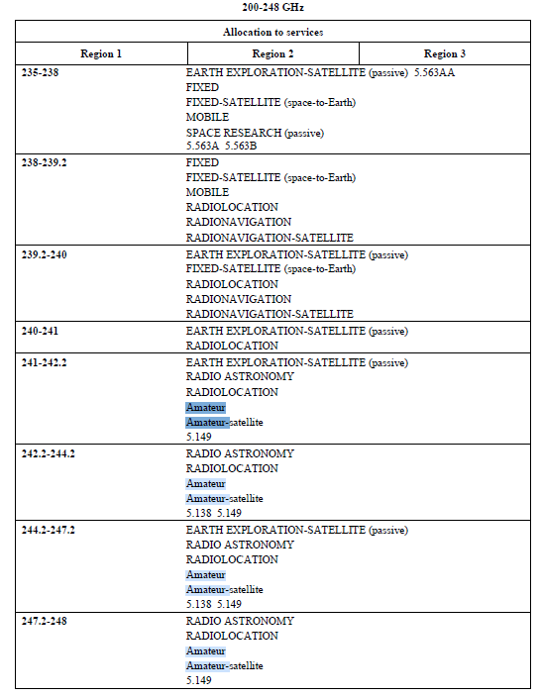

RESOLUTION 32 (REV.WRC-23)
Regulatory procedures for frequency assignments to non-geostationary-satellite
networks or systems identified as short-duration mission not subject to the
application of Section II of Article 9
The World Radiocommunication Conference (Dubai, 2023),
considering
a) that some non-geostationary (non-GSO) satellites with short-duration missions have, to
date, been operating for their entire mission duration without being notified or recorded;
b) that successful and timely development and operation of non-GSO networks or systems
with short-duration missions may require regulatory procedures which take account of the short
development cycle, short lifetimes and typical missions of such satellites, and therefore the
application of certain provisions of Articles 9 and 11 may need to be adapted to take account of the
nature of these satellites;
c) that these satellites typically have a short (one to two years) development time and are
low cost, often using off-the-shelf components;
d) that the operational lifetime of these satellites generally ranges from several weeks up to
not more than three years;
e) that non-GSO satellites with short-duration missions utilize low-Earth orbits;
f) that non-GSO satellites with short-duration missions are being used for a wide variety of
applications, including remote sensing, space weather research, upper atmosphere research,
astronomy, communications, technology demonstration and education, and therefore may operate
under various radiocommunication services;
g) that advances in the field of satellite technology have resulted in non-GSO satellites with
short-duration missions becoming a means for developing countries to become involved in space
activities,
considering further
a) that the application of provisions of Articles 9 and 11 to frequency assignments to non-
GSO networks or systems identified as short-duration mission as prescribed in this Resolution should
not adversely or otherwise affect the regulatory treatment of other systems;
b) that the application of any modified regulatory procedure should not change the sharing
status with respect to networks and systems not applying the modified regulatory procedure, both
terrestrial and space, in frequency bands which may be used by non-GSO systems with short-duration
missions,
recognizing
a) that Resolution ITU-R 68 seeks to improve awareness and increase knowledge on
existing regulatory procedures for small satellites;
b) that non-GSO networks or systems operating in frequency bands not subject to Section II
of Article 9 are, irrespective of the period of validity of their associated frequency assignments,
subject to Nos. 9.3 and 9.4;
c) that non-GSO systems with short-duration missions are not to be used for safety-of-life
services,
noting
a) Report ITU-R SA.2312, on characteristics, definitions and spectrum requirements of
nanosatellites and picosatellites, as well as systems composed of such satellites;
b) that No. 22.1 states that “Space stations shall be fitted with devices to ensure immediate
cessation of their radio emissions by telecommand, whenever such cessation is required under the
provisions of these Regulations” (see also Appendix 4 data item A.24.a),
resolves
1 that this Resolution shall apply only to non-GSO networks or systems identified by the
notifying administration as effecting short-duration missions and corresponding to the following
criteria:
1.1 the network or system shall operate under any space radiocommunication service on
frequency assignments that are not subject to the application of Section II of Article 9;
1.2 the maximum period of operation and validity of frequency assignments of a non-GSO
network or system identified as short-duration mission shall not exceed three years from the date of
bringing into use of the frequency assignments (see the Annex to this Resolution for the definition of
date of bringing into use for such networks or systems), without any possibility of extension, after
which the recorded assignments shall be cancelled;
1.3 the total number of satellites in a non-GSO network or system identified as short-duration
mission shall not exceed 10 satellites1;
2 that non-GSO networks or systems corresponding to resolves 1 of this Resolution shall
comply with the conditions for use of the frequency band that is allocated to the service within which
they operate;
3 that non-GSO networks or systems identified as short-duration mission using spectrum
allocated to the amateur-satellite service shall operate in accordance with the definition of the
amateur-satellite service as contained in Article 25;
RESOLUTION 223 (REV.WRC-23)
Additional frequency bands identified for International
Mobile Telecommunications
The World Radiocommunication Conference (Dubai, 2023),
considering
a) that International Mobile Telecommunications (IMT), including IMT-2000,
IMT-Advanced and IMT-2020, is the ITU vision of global mobile access;
b) that IMT systems provide telecommunication services on a worldwide scale regardless of
location, network or terminal used;
c) that IMT provides access to a wide range of telecommunication services supported by
fixed telecommunication networks (e.g. public switched telephone network (PSTN)/integrated
services digital network (ISDN), high bit rate Internet access), and to other services which are specific
to mobile users;
d) that the technical characteristics of IMT are specified in ITU Radiocommunication Sector
(ITU-R) and ITU Telecommunication Standardization Sector (ITU-T) Recommendations, including
Recommendations ITU-R M.1457 and ITU-R M.2012, which contain the detailed specifications of
the terrestrial radio interfaces of IMT;
e) that the evolution of IMT is being studied within ITU-R;
f) that the review of IMT-2000 spectrum requirements at WRC-2000 concentrated on the
frequency bands below 3 GHz;
g) that at WARC-92, 230 MHz of spectrum was identified for IMT-2000 in the frequency
bands 1 885-2 025 MHz and 2 110-2 200 MHz, including the frequency bands 1 980-2 010 MHz and
2 170-2 200 MHz for the satellite component of IMT-2000, in No. 5.388 and under the provisions of
Resolution 212 (Rev.WRC-23);
h) that since WARC-92 there has been a tremendous growth in mobile communications
including an increasing demand for broadband multimedia capability;
i) that the frequency bands identified for IMT are currently used by mobile systems or
applications of other radiocommunication services;
j) that Recommendation ITU-R M.1308 addresses the evolution of existing mobile
communication systems to IMT-2000, and that Recommendation ITU-R M.1645 addresses the
evolution of the IMT systems and maps out their future development;
k) that harmonized worldwide frequency bands for IMT are desirable in order to achieve
global roaming and the benefits of economies of scale;
l) that the frequency bands 1 710-1 885 MHz, 2 500-2 690 MHz and 3 300-3 400 MHz are
allocated to a variety of services in accordance with the relevant provisions of the Radio Regulations;
m) that the frequency band 2 300-2 400 MHz is allocated to the mobile service on a
co-primary basis in the three ITU Regions;
n) that the frequency band 2 300-2 400 MHz, or portions thereof, is used extensively in a
number of administrations by other services including the aeronautical mobile service (AMS) for
telemetry in accordance with the relevant provisions in the Radio Regulations;
o) that IMT has already been deployed or is being considered for deployment in some
countries in the frequency bands 1 710-1 885 MHz, 2 300-2 400 MHz and 2 500-2 690 MHz and
equipment is readily available;
p) that the frequency bands 1 710-1 885 MHz, 2 300-2 400 MHz and 2 500-2 690 MHz, or
parts thereof, are identified for use by administrations wishing to implement IMT;
q) that technological advancement and user needs will promote innovation and accelerate
the delivery of advanced communication applications to consumers;
r) that changes in technology may lead to the further development of communication
applications, including IMT;
s) that timely availability of spectrum is important to support future applications;
t) that IMT systems are envisaged to provide increased peak data rates and capacity that
may require a larger bandwidth;
u) that ITU-R studies forecasted that additional spectrum may be required to support the
future services of IMT and to accommodate future user requirements and network deployments;
v) that the frequency band 1 427-1 429 MHz is allocated to the mobile, except aeronautical
mobile, service in all three Regions on a primary basis;
w) that the frequency band 1 429-1 525 MHz is allocated to the mobile service in Regions 2
and 3 and to the mobile, except aeronautical mobile, service in Region 1 on a primary basis;
x) that the frequency band 1 518-1 559 MHz is allocated in all three Regions to the mobilesatellite
service (MSS) on a primary basis1;
y) that WRC-15 identified the frequency band 1 427-1 518 MHz for use by administrations
wishing to implement terrestrial IMT systems;
z) that there is a need to ensure the continued operations of the MSS in the frequency band
1 518-1 525 MHz;
aa) that appropriate technical measures to facilitate adjacent frequency band compatibility
between the MSS in the frequency band 1 518-1 525 MHz and IMT in the frequency band
1 492-1 518 MHz need to be studied;
ab) Report ITU-R RA.2332, on compatibility and sharing studies between the radio
astronomy service and IMT systems in the frequency bands 608-614 MHz, 1 330-1 400 MHz,
1 400-1 427 MHz, 1 610.6-1 613.8 MHz, 1 660-1 670 MHz, 2 690-2 700 MHz, 4 800-4 990 MHz
and 4 990-5 000 MHz;
ac) that WRC-15, WRC-19 and this conference have identified the frequency band 3 300-
3 400 MHz for use by administrations wishing to implement terrestrial IMT systems in Nos. 5.429B,
5.429D and 5.429F;
ad) that the frequency band 3 100-3 400 MHz is allocated worldwide on a primary basis to
the radiolocation service;
ae) that a number of administrations use the frequency band 3 300-3 400 MHz, or portions
thereof, which is allocated to the fixed and mobile services on a primary basis in No. 5.429;
af) that the frequency band 4 800-4 990 MHz is allocated worldwide to the mobile and fixed
services on a primary basis;
ag) that the frequency band 4 800-4 990 MHz is identified for use by administrations wishing
to implement terrestrial IMT systems in countries listed in Nos. 5.441A and 5.441B;
ah) that appropriate technical measures may be considered by administrations at a national
level to facilitate adjacent frequency band compatibility between radio astronomy receivers in the
frequency band 4 990-5 000 MHz and IMT systems in the frequency band 4 800-4 990 MHz;
ai) that Report ITU-R M.2481 addresses in-band and adjacent-band coexistence and
compatibility studies between IMT systems in the frequency band 3 300-3 400 MHz and
radiolocation systems in the frequency band 3 100-3 400 MHz, and that further studies were carried
out in preparation for this conference;
aj) that the development of new ITU-R Recommendations and/or Reports could provide
guidance to support administrations planning to implement IMT, to ensure co-existence with the
radiolocation service operating in neighbouring countries in the frequency band 3 300-3 400 MHz,
emphasizing
a) that flexibility must be afforded to administrations:
– to determine, at a national level, how much spectrum to make available for IMT from
within the identified frequency bands;
– to develop their own transition plans, if necessary, tailored to meet their specific
deployment of existing systems;
– to have the ability for the identified frequency bands to be used by all services having
allocations in those frequency bands;
– to determine the timing of availability and use of the frequency bands identified for IMT,
in order to meet particular user demand and other national considerations;
b) that the particular needs of developing countries must be met;
c) that Recommendation ITU-R M.819 describes the objectives to be met by IMT-2000 in
order to meet the needs of developing countries,
noting
a) Resolutions 224 (Rev.WRC-23) and 225 (Rev.WRC-23), which also relate to IMT;
b) that the sharing implications between services sharing the frequency bands identified for
IMT in No. 5.384A, as relevant, will need further study in ITU-R;
c) that studies regarding the availability of the frequency band 2 300-2 400 MHz for IMT
are being conducted in many countries, the results of which could have implications for the use of
those frequency bands in those countries;
d) that, due to differing requirements, not all administrations may need all of the IMT
frequency bands identified at WRC-07, or, due to the usage by and investment in existing services,
may not be able to implement IMT in all of those frequency bands;
e) that the spectrum for IMT identified by WRC-07 may not completely satisfy the expected
requirements of some administrations;
f) that currently operating mobile communication systems may evolve to IMT in their
existing frequency bands;
g) that services such as the fixed service, the mobile service (second-generation systems),
the space operation service, the space research service and the AMS are in operation or planned in
the frequency band 1 710-1 885 MHz, or portions thereof;
h) that in the frequency band 2 300-2 400 MHz, or portions thereof, there are services such
as the fixed, mobile, amateur and radiolocation services which are currently in operation or planned
to be in operation in the future;
i) that services such as the broadcasting-satellite service (BSS), the BSS (sound), the MSS
(in Region 3) and the fixed service (including multipoint distribution/communication systems) are in
operation or planned in the frequency band 2 500-2 690 MHz, or portions thereof;
j) that the identification of several frequency bands for IMT allows administrations to
choose the best frequency band or parts thereof for their circumstances;
k) that further study of the technical and operational measures regarding adjacent frequency
band compatibility between IMT systems operating below 3 400 MHz and fixed-satellite service
earth stations operating above 3 400 MHz may be required;
l) that ITU-R has identified additional work to address further developments in IMT;
m) that the IMT terrestrial radio interfaces as defined in Recommendations ITU-R M.1457
and ITU-R M.2012 are expected to evolve within the framework of ITU-R beyond those initially
specified, in order to provide enhanced services and services beyond those envisaged in the initial
implementation;
n) that the identification of a frequency band for IMT does not establish priority in the Radio
Regulations and does not preclude the use of the frequency band for any application of the services
to which it is allocated;
o) that the provisions of Nos. 5.317A, 5.384A, 5.388, 5.429B, 5.429D, 5.429F, 5.441A
and 5.441B do not prevent administrations from having the choice to implement other technologies
in the frequency bands identified for IMT, based on national requirements,
recognizing
that, for some administrations, the only way of implementing IMT would be spectrum refarming,
requiring significant financial investment,
resolves
1 to invite administrations planning to implement IMT to make available, based on user
demand and other national considerations, additional frequency bands or portions of the frequency
bands above 1 GHz identified in Nos. 5.341B, 5.384A, 5.429B, 5.429D, 5.429F, 5.441A and 5.441B
for the terrestrial component of IMT; due consideration should be given to the benefits of harmonized
utilization of the spectrum for the terrestrial component of IMT, taking into account the services to
which the frequency band is currently allocated;
2 to acknowledge that the differences in the texts of Nos. 5.341B, 5.384A and 5.388 do not
confer differences in regulatory status;
3 that, in the frequency bands 4 800-4 825 MHz and 4 835-4 950 MHz, in order to identify
potentially affected administrations when applying the procedure for seeking agreement under
No. 9.21 for IMT stations in relation to aircraft stations, a coordination distance from an IMT station
to the border of another country equal to 300 km (for land path)/450 km (for sea path) applies;
4 that in the frequency band 4 800-4 990 MHz, in order to identify potentially affected
administrations when applying the procedure for seeking agreement under No. 9.21 for IMT stations
in relation to fixed-service stations or other ground-based stations of the mobile service, a
coordination distance from an IMT station to the border of another country equal to 70 km applies;
5 that the power flux-density (pfd) limits in No. 5.441B shall not apply to the following
countries: Armenia, Brazil, Cambodia, China, Russian Federation, Kazakhstan, Lao P.D.R.,
Uzbekistan, South Africa, Viet Nam and Zimbabwe,
invites the ITU Radiocommunication Sector
1 to continue providing guidance to ensure that IMT can meet the telecommunication needs
of developing countries and rural areas;
2 to continue providing guidance to administrations planning to facilitate the
implementation of IMT in the frequency band 3 300-3 400 MHz, taking into account considering aj;
3 to include the results of the studies mentioned in invites the ITU Radiocommunication
Sector above in one or more ITU-R Recommendations and Reports, as appropriate.

RESOLUTION 680 (WRC-23)
Studies on frequency-related matters, including possible new
or modified space research service (space-to-space) allocations,
for future development of communications on the lunar surface
and between lunar orbit and the lunar surface
The World Radiocommunication Conference (Dubai, 2023),
considering
a) that there is increased interest in conducting scientific discovery and space exploration
activities in lunar orbit and on the lunar surface;
b) that wireless communication technology is well-developed and widely deployed on the
Earth and could be applied to lunar communications;
c) that point-to-multipoint systems on the lunar surface used for scientific or technological
research purposes could operate in the space research service (SRS) (space-to-space) currently;
d) that lunar missions may require signals for accurate Positioning, Navigation and Timing
(PNT) in the lunar region originating from Moon-orbiting satellites;
e) that the lunar environment has unique atmospheric, soil and topographic conditions;
f) that the shielded zone of the Moon (SZM) and the absence of appreciable water vapour
and oxygen in the lunar atmosphere allow for radioastronomical observations which are not possible
on Earth;
g) that the interests of scientific discovery and space exploration are of a global nature;
h) that lunar scientific and exploration activities can advance the development of potential
future space activities beyond space research, which may in the future include other relevant
radiocommunication services for lunar communications,
noting
a) that Section V of Article 22 addresses protection of radio astronomy in the SZM;
b) that Recommendation ITU-R RA.479-5 relates to the protection of frequencies for
radioastronomical measurements in the SZM, with a view to preserving the unique radioastronomical
capabilities in this zone;
c) that the impact of unintended electromagnetic radiation from electrical and electronic
systems into radio astronomy receivers should be assessed (see Question ITU-R 243/1);
RES680
– 598 –
recognizing
a) that studies on sharing and compatibility between potential systems on the Moon’s
surface and systems orbiting the Moon would need to take into account any existing SRS applications
and other affected services in the same or, as appropriate, adjacent bands;
b) that frequencies for communications between the Earth and the Moon are provided
through the existing allocations to the SRS;
c) that frequencies for communications between satellites orbiting the Moon can operate in
existing frequency allocations to the SRS (space-to-space) and the inter-satellite service;
d) that existing allocations to the amateur radio service have also been used for
communications between the Earth and the Moon, and Earth-to-Earth via passive reflection from the
Moon;
e) that dedicated frequencies are needed in the lunar vicinity for local communications
between systems operating on the lunar surface and between systems in lunar orbit and systems on
the lunar surface;
f) that future development of communications on the lunar surface and between lunar orbit
and the lunar surface should take into account the need to maintain the opportunities for radio
astronomy observations and the operation of space research sensors, including active and passive
sensors on the Moon;
g) that the frequency bands 7 190-7 235 MHz (Earth-to-space) and 8 450-8 500 MHz
(space-to-Earth) are allocated to the SRS on a primary basis;
h) that the frequency band 5 250-5 570 MHz is allocated to the SRS (active) on a primary
basis;
i) that the frequency bands 3 500-3 800 MHz (space-to-Earth) and 5 725-5 925 MHz
(Earth-to-space) are allocated to the fixed-satellite service on a primary basis;
j) that the frequency band 25.25-27.5 GHz is allocated to the inter-satellite service on a
primary basis, limited to space research and Earth exploration-satellite applications, and also
transmissions of data originating from industrial and medical activities in space, as stipulated in
No. 5.536;
k) that the fixed and mobile (in some bands mobile, except aeronautical mobile) services are
allocated on a primary basis within the frequency ranges 390-399.9 MHz, 400.05-401 MHz by
No. 5.262, 420-430 MHz, 440-450 MHz, 2 400-2 690 MHz, 3 500-3 800 MHz, 5 650-5 850 MHz by
No. 5.453, 7 190-7 235 MHz, 8 450-8 500 MHz and 25.25-28.35 GHz;
l) that the mobile, except aeronautical mobile, service is allocated on a primary basis in the
frequency ranges 5 150-5 350 MHz and 5 470-5 725 MHz, the aeronautical mobile service is
allocated on a primary basis under Nos. 5.446C and 5.446D in the frequency band 5 150-5 250 MHz,
the fixed service is allocated on a primary basis under No. 5.447E in the frequency band 5 250-
5 350 MHz and the fixed service is allocated on a primary basis in the frequency band 5 670-
5 850 MHz in No. 5.455;
RES680
– 599 –
m) that the aeronautical radionavigation service is allocated on a primary basis in the frequency
bands 5 150-5 250 MHz and 5 350-5 460 MHz and by No. 5.450 in the frequency band 5 470-
5 650 MHz, the radionavigation service is allocated on a primary basis in the frequency band 2 450-
2 500 MHz (Regions 2 and 3), in the frequency band 5 250-5 350 by No. 5.448 and in the frequency
band 5 460-5 470 MHz, the maritime radionavigation is allocated on a primary basis in the frequency
range 5 470-5 650 MHz, the radiolocation service (RLS) is allocated on a primary basis in the
frequency range 5 250-5 850 MHz, and the RLS is allocated on a primary basis under No. 5.269 in
the frequency bands 420-430 MHz and 440-450 MHz,
n) that the broadcasting-satellite service (BSS) is allocated on a primary basis in the frequency
range 2 520-2 670 MHz, and the BSS (sound) and complementary terrestrial sound broadcasting
service are allocated on a primary basis under No. 5.418 in the frequency band 2 535-2 565 MHz;
resolves to invite the ITU Radiocommunication Sector to complete in time for the
2027 world radiocommunication conference
1 studies of the spectrum needs of systems in the SRS which may operate on the lunar
surface, or systems in lunar orbit communicating with systems on the lunar surface, in the following
frequency ranges or portions thereof, taking into account noting a), b) and c):
– 390-406.1 MHz, 420-430 MHz and 440-450 MHz, limited to outside the SZM
– 2 400-2 690 MHz, 3 500-3 800 MHz, 5 150-5 570 MHz, 5 570-5 725 MHz, 5 775-
5 925 MHz, 7 190-7 235 MHz, 8 450-8 500 MHz and 25.25-28.35 GHz;
2 studies of the technical and operational characteristics, as well as protection criteria, of
systems in the SRS that are planned for operation in the frequency bands in resolves to invite the ITU
Radiocommunication Sector to complete in time for the 2027 world radiocommunication
conference 1, as well as protection criteria to be applied for the protection of the radio astronomy
service (RAS) and SRS active and passive sensors on the lunar surface and lunar orbit;
3 studies of the propagation considerations for lunar surface systems and lunar-orbiting
systems operating in the frequency ranges in resolves to invite the ITU Radiocommunication Sector
to complete in time for the 2027 world radiocommunication conference 1;
4 studies of sharing and compatibility related to systems in the SRS that are planned for
operation in the frequency ranges identified in resolves to invite the ITU Radiocommunication Sector
to complete in time for the 2027 world radiocommunication conference 1 to ensure protection of:
– radiocommunication services, as specified in recognizing g) to n), and
– the RAS on the Earth and in the SZM in the same, adjacent or nearby bands;
5 studies of potential new or modified frequency allocations and/or identifications to the
SRS with appropriate regulatory provisions, for communications on the lunar surface or in lunar orbit
communicating with systems on the lunar surface,
RES680
– 600 –
invites the ITU Radiocommunication Sector
1 to begin studying, taking into account considering h), future spectrum needs for lunar
communications and systems, beyond those identified in resolves to invite the ITU
Radiocommunication Sector to complete in time for the 2027 world radiocommunication
conference 1, which may be needed for communications between the Earth, lunar-orbiting spacecraft
and the lunar surface;
2 to study whether future radiocommunications in the vicinity of the Moon, as described in
considering h), can be accommodated within existing space radiocommunication services and
whether the regulatory provisions described in the Radio Regulations are sufficient,
invites administrations
to participate in the studies by submitting contributions to the ITU Radiocommunication Sector,
invites the 2027 world radiocommunication conference
to consider, based on the results of the studies referred to in resolves to invite the ITU
Radiocommunication Sector to complete in time for the 2027 world radiocommunication
conference 1 to 5, new or modified allocations and/or identifications in the SRS in the frequency
ranges in resolves to invite the ITU Radiocommunication Sector to complete in time for the
2027 world radiocommunication conference 1 above, or portions thereof, for use in the vicinity of
the Moon,
instructs the Director of the Radiocommunication Bureau
to report to WRC-27 on the progress of the studies referred to in invites the ITU Radiocommunication
Sector 1 and 2 above,
invites a future competent world radiocommunication conference after WRC-27
to consider, if necessary, appropriate regulatory actions based upon the studies called for in invites
the ITU Radiocommunication Sector 1 and 2 above.

RESOLUTION 686 (WRC-23)
Possible secondary allocation to the Earth exploration-satellite service (active)
in the frequency bands [3 000-3 100 MHz] and [3 300-3 400 MHz]*
The World Radiocommunication Conference (Dubai, 2023),
considering
a) that spaceborne active radio-frequency sensors can provide unique information on the
physical properties of the Earth;
b) that spaceborne active remote sensing requires specific frequency ranges, depending on
the physical phenomena to be observed;
c) that there is an interest in using active spaceborne sensors in the 3 GHz frequency range
primarily for measurement of ice boundaries, type and age, ocean wave structure, ocean wind speed
and direction and mapping of ocean circulation (currents and eddies);
d) that the frequency band 3 100-3 300 MHz is already allocated to the Earth explorationsatellite
service (EESS) (active) on a secondary basis and is currently being used for altimeters and
synthetic aperture radars (SARs);
e) that a frequency band of at least 400 MHz is preferable to satisfy the requirements for
high-resolution SARs;
f) that SARs in the 3 GHz frequency range are not intended to be operated in populated
areas of the globe, but primarily over oceans and seas,
recognizing
a) that the frequency band 3 000-3 100 MHz is allocated to the radiolocation service (RLS)
and radionavigation service on a primary basis;
b) that the frequency band 3 300-3 400 MHz is allocated to the RLS on a primary basis;
c) that the frequency band 3 300-3 400 MHz is also allocated to the amateur service on a
secondary basis in Regions 2 and 3;
d) that the frequency band 3 300-3 400 MHz is also allocated to the fixed and mobile
services on a secondary basis in Region 2;
e) that the frequency band 3 300-3 400 MHz is also allocated to the fixed and mobile, except
aeronautical mobile, services on a primary basis in certain countries under Nos. 5.429A, 5.429C
and 5.429E;
_______________
* The appearance of square brackets around certain frequency bands in this Resolution is understood to mean that
WRC-27 will consider and review the inclusion of these frequency bands with square brackets and decide, as appropriate.
RES686
– 617 –
f) that the frequency band 3 300-3 400 MHz is identified for the implementation of
International Mobile Telecommunications in certain countries in Regions 1 and 2 under Nos. 5.429B
and 5.429D;
g) that, in accordance with No. 5.149, administrations are urged to take all practicable steps
to protect the radio astronomy service from harmful interference in the frequency bands 3 332-
3 339 MHz and 3 345.8-3 352.5 MHz,
resolves to invite the ITU Radiocommunication Sector to complete in time for the 2031
world radiocommunication conference
studies on spectrum needs and studies on the possibility of sharing between the EESS (active) and
incumbent radio services in the frequency bands [3 000-3 100 MHz] and [3 300-3 400 MHz],
invites the 2031 world radiocommunication conference
to consider the results of studies for a possible new secondary allocation to the EESS (active) for
spaceborne SARs in the frequency bands [3 000-3 100 MHz] and [3 300-3 400 MHz], taking into
account the protection of incumbent services, and take appropriate action,
invites administrations
to participate actively in the studies by submitting contributions to the ITU Radiocommunication
Sector.

RESOLUTION 721 (WRC-23)
Studies on potential new allocations to fixed, mobile, radiolocation,
amateur, amateur-satellite, radio astronomy, Earth exploration-satellite
(passive and active) and space research (passive) services
in the frequency range 275-325 GHz with the consequential update
of Nos. 5.149, 5.340, 5.564A and 5.565
The World Radiocommunication Conference (Dubai, 2023),
considering
a) that technologies above 275 GHz are considered as emerging enablers to enhance the
radio interface to support high-capacity transmission and scientific research;
b) that sub-terahertz and terahertz spectrum have been discussed for use by various active
service applications;
c) that there have been radio observatories and passive remote sensing satellites operating
above 275 GHz;
d) that studies on technical and operational characteristics of fixed service and land mobile
service (LMS) applications operating in the frequency range 275-450 GHz have been carried out by
the ITU Radiocommunication Sector (ITU-R) and resulted in No. 5.564A being added by WRC-19;
e) that amateur and amateur satellite service applications have been utilized in the frequency
range 275-450 GHz in a number of countries;
f) that Recommendation ITU-R RS.2017 provides performance and interference criteria for
satellite passive remote sensing up to 1 000 GHz;
g) that protection criteria for the radio astronomy service (RAS) above 275 GHz is included
in Report ITU-R RA.2189;
h) that frequency bands above 275 GHz in which emissions are prohibited are not specified
by a provision of the Radio Regulations;
i) that propagation characteristics of frequencies above 275 GHz are being studied by
ITU-R Study Group 3;
j) that international standards are being developed for equipment operating in the frequency
range 275-450 GHz;

k) that it is appropriate to ensure that any frequency allocations above 275 GHz to the fixed,
land mobile, radiolocation, amateur, amateur-satellite, radio astronomy and Earth explorationsatellite
(passive and active), space research (passive) and any other radiocommunication services
should correspond to up-to-date technical and operational characteristics for those applications and
take into account compatibility between these services,
noting
a) that Nos. 5.564A and 5.565 apply to the frequency range 275-450 GHz;
b) that Reports ITU-R F.2416, ITU-R M.2417 and ITU-R RS.2431 provide technical and
operational characteristics of fixed service, LMS and Earth exploration-satellite service (EESS)
(passive) applications in the frequency range 275-450 GHz, respectively;
c) that Report ITU-R SM.2352 contains technology trends of active services in the
frequency range 275-3 000 GHz;
d) that Report ITU-R SM.2540 provides sharing and compatibility study results between
land mobile, fixed and passive services in the frequency range 275-450 GHz;
e) that Report ITU-R RS.2194 contains passive bands of scientific interest to the
EESS/space research service (SRS) from 275 to 3 000 GHz,
recognizing
a) that the frequency range 275-325 GHz is also identified for other radiocommunication
services and that those identifications are used by a variety of incumbent systems in many
administrations, and that the protection of these services, including adjacent services, should be
studied;
b) that for the determination of the incumbent services, the relevant provisions of the Radio
Regulations in force apply;
c) that identifications do not preclude the use of the frequency bands by any application of
the services to which the frequency bands are identified and do not establish priority over any other
applications of radiocommunication services;
d) that the frequency bands 296-306 GHz, 313-318 GHz and 333-356 GHz may only be
used by fixed and land mobile service applications when specific conditions to ensure the protection
of EESS) (passive) applications are determined in accordance with Resolution 731 (Rev.WRC-23);
e) that in the frequency bands 275-323 GHz, 327-371 GHz, 388-424 GHz and
426-442 GHz, where radio astronomy applications are used, specific conditions (e.g. minimum
separation distances and/or avoidance angles) may be necessary to ensure protection of radio
astronomy sites from land mobile and/or fixed service applications, on a case-by-case basis in
accordance with Resolution 731 (Rev.WRC-23),
RES721
– 628 –
resolves to invite the ITU Radiocommunication Sector to complete in time for the 2031
world radiocommunication conference
1 studies on the spectrum needs for the fixed, mobile, radiolocation, amateur, amateursatellite,
radio astronomy, Earth exploration-satellite (passive and active) and space research (passive)
services in the frequency range 275-325 GHz;
2 studies on sharing and compatibility between services referenced in resolves to invite the
ITU Radiocommunication Sector to complete in time for the 2031 world radiocommunication
conference 1;
3 studies on possible new allocations to services referenced in resolves to invite the ITU
Radiocommunication Sector to complete in time for the 2031 world radiocommunication
conference 1, while ensuring the protection of passive services in the frequency range 275-325 GHz
and adjacent frequency bands, taking into account the frequency bands identified in Nos. 5.564A
and 5.565, and the results of the studies under resolves to invites the ITU Radiocommunication Sector
to complete in time for the 2031 world radiocommunication conference 1 and 2,
invites the 2031 world radiocommunication conference
based on the results of the studies, to consider potential new allocations in the frequency range 275-
325 GHz for radiocommunication services referenced in resolves to invite the ITU
Radiocommunication Sector to complete in time for the 2031 world radiocommunication
conference 1 and update Nos. 5.149, 5.340, 5.564A and 5.565, as appropriate,
encourages administrations
to participate actively in the studies and provide the information required for the studies listed under
resolves to invite the ITU Radiocommunication Sector to complete in time for the 2031 world
radiocommunication conference by submitting contributions to the ITU Radiocommunication Sector,
instructs the Secretary-General
to bring this Resolution to the attention of the international and regional organizations concerned.

RESOLUTION 814 (WRC-23)
Preliminary agenda for the 2031 world radiocommunication conference*
The World Radiocommunication Conference (Dubai, 2023),
considering
a) that, in accordance with No. 118 of the ITU Convention, the general scope of the agenda
for WRC-31 should be established four to six years in advance;
b) Article 13 of the ITU Constitution, relating to the competence and scheduling of world
radiocommunication conferences (WRCs), and Article 7 of the Convention, relating to their agendas;
c) the relevant resolutions and recommendations of previous world administrative radio
conferences (WARCs) and WRCs,
resolves to give the view
that the following items should be included in the preliminary agenda for WRC-31:
1 to take appropriate action in respect of those urgent issues that were specifically requested
by WRC-27;
2 on the basis of proposals from administrations and the Report of the Conference
Preparatory Meeting, and taking account of the results of WRC-27, to consider and take appropriate
action in respect of the following items:
2.1 to consider potential new allocations to the fixed, mobile, radiolocation, amateur,
amateur-satellite, radio astronomy, Earth exploration-satellite (passive and active) and space research
(passive) services in the frequency range 275-325 GHz in the Table of Frequency Allocations of the
Radio Regulations, with the consequential update of Nos. 5.149, 5.340, 5.564A and 5.565, in
accordance with Resolution 721 (WRC-23);
2.2 [to consider the possible [frequency bands] for [non-beam and beam] wireless power
transmission to avoid harmful interference to the radiocommunication services caused by wireless
power transmission, in accordance with Resolution 910 (WRC-23)];
2.3 to consider the use of aeronautical and maritime earth stations in motion communicating
with non-geostationary space stations in the fixed-satellite service (Earth-to-space) in the frequency
band 12.75-13.25 GHz, in accordance with Resolution 133 (WRC-23);
2.4 to consider, based on the results of ITU Radiocommunication Sector studies, support for
inter-satellite service allocations in the frequency bands 3 700-4 200 MHz and 5 925-6 425 MHz, and
associated regulatory provisions, to enable links between non-geostationary orbit satellites and
geostationary orbit satellites, in accordance with Resolution 683 (WRC-23);
2.5 to consider a possible primary allocation in the frequency bands [694-960 MHz, or parts
thereof, in Region 1], 890-942 MHz, or parts thereof, in Region 2, and [3 400-3 700 MHz, or parts
thereof, in Region 3] to the aeronautical mobile service for the use of International Mobile
Telecommunications (IMT) user equipment in terrestrial IMT networks by non-safety applications,
in accordance with Resolution 251 (Rev.WRC-23);
2.6 to consider the identification of the frequency bands [102-109.5 GHz, 151.5-164 GHz,
167-174.8 GHz, 209-226 GHz and 252-275 GHz] for International Mobile Telecommunications, in
accordance with Resolution 255 (WRC-23);
2.7 to consider improving the utilization of VHF maritime radiocommunication, in
accordance with Resolution 363 (Rev.WRC-23);
2.8 to consider improving the utilization and channelization of maritime radiocommunication
in the MF and HF bands, including potential revisions of Article 52 and Appendix 17, in accordance
with Resolution 366 (WRC-23);
2.9 to consider possible new allocations to the radionavigation-satellite service (space-to-
Earth) in the frequency bands [5 030-5 150 MHz and 5 150-5 250 MHz] or parts thereof, in
accordance with Resolution 684 (WRC-23);
2.10 to consider a possible new primary allocation to the Earth exploration-satellite service
(Earth-to-space) in the frequency band 22.55-23.15 GHz, in accordance with
Resolution 664 (Rev.WRC-23);
2.11 to consider an upgrade of the secondary allocation to the Earth exploration-satellite
service (space-to-Earth) in the frequency band [37.5-40.5 GHz] or possible new worldwide frequency
allocations on a primary basis to the Earth exploration-satellite service (space-to-Earth) in certain
frequency bands within the frequency range [40.5-52.4 GHz], in accordance with
Resolution 685 (WRC-23);
2.12 to consider possible new allocations to the Earth exploration-satellite service (active) in
the frequency bands [3 000-3 100 MHz] and [3 300-3 400 MHz] on a secondary basis, in accordance
with Resolution 686 (WRC-23);
2.13 to consider studies on coexistence between spaceborne synthetic aperture
radars operating in the Earth exploration-satellite service (active) and the radiodetermination service
in the frequency band 9 200-10 400 MHz, with possible actions as appropriate, in accordance with
Resolution 722 (WRC-23);
2.14 to review spectrum use and needs of applications of broadcasting and mobile services and
consider possible regulatory actions in the frequency band 470-694 MHz or parts thereof, in
accordance with Resolution 235 (Rev.WRC-23);
3 to examine the revised ITU Radiocommunication Sector Recommendations incorporated
by reference in the Radio Regulations communicated by the Radiocommunication Assembly, in
accordance with further resolves of Resolution 27 (Rev.WRC-19), and to decide whether or not to
update the corresponding references in the Radio Regulations, in accordance with the principles
contained in resolves of that Resolution;
4 to consider such consequential changes and amendments to the Radio Regulations as may
be necessitated by the decisions of the conference;
5 in accordance with Resolution 95 (Rev.WRC-19), to review the Resolutions and
Recommendations of previous conferences with a view to their possible revision, replacement or
abrogation;
6 to review, and take appropriate action on, the Report from the Radiocommunication
Assembly submitted in accordance with Nos. 135 and 136 of the ITU Convention;
7 to identify those items requiring urgent action by the radiocommunication study groups;
8 to consider possible changes, in response to Resolution 86 (Rev. Marrakesh, 2002) of the
Plenipotentiary Conference, on advance publication, coordination, notification and recording
procedures for frequency assignments pertaining to satellite networks, in accordance with
Resolution 86 (Rev.WRC-07), in order to facilitate the rational, efficient and economical use of radio
frequencies and any associated orbits, including the geostationary-satellite orbit;
9 to consider and take appropriate action on requests from administrations to delete their
country footnotes or to have their country name deleted from footnotes, if no longer required, taking
into account Resolution 26 (Rev.WRC-23);
10 to consider and approve the Report of the Director of the Radiocommunication Bureau,
in accordance with Article 7 of the ITU Convention:
10.1 on the activities of the Radiocommunication Sector since WRC-271;
10.2 on any difficulties or inconsistencies encountered in the application of the Radio
Regulations2; and
10.3 on action in response to Resolution 80 (Rev.WRC-07);
_______________
1 This WRC’s standing sub-item is strictly limited to the Report of the Director on ITU-R activities since the last WRC;
and any topics outside 2.1-2.14 as listed above shall be strictly avoided, particularly those topics which require any
changes/amendments to the Radio Regulations.
2 This agenda sub-item is strictly limited to the Report of the Director on any difficulties or inconsistencies encountered
in the application of the Radio Regulations and the comments from administrations. Administrations are invited to inform
the Director of the Radiocommunication Bureau of any difficulties or inconsistencies encountered in the Radio
Regulations.
11 to recommend to the ITU Council items for inclusion in the agenda for the next world
radiocommunication conference, and items for the preliminary agenda of future conferences, in
accordance with Article 7 of the ITU Convention and Resolution 804 (Rev.WRC-23),
invites the ITU Council
to finalize the agenda and arrange for the convening of WRC-31, and to initiate as soon as possible
the necessary consultations with Member States,
instructs the Director of the Radiocommunication Bureau
1 to make the necessary arrangements to convene meetings of the Conference Preparatory
Meeting (CPM) and to prepare a report to WRC-31;
2 to submit a draft Report on any difficulties or inconsistencies encountered in the
application of the Radio Regulations, as referred to in agenda item 10.2, to the second session of the
CPM and to submit the final Report at least five months before the next WRC,
instructs the Secretary-General
to communicate this Resolution to international and regional organizations concerned.

