Aggregated interference from satellite systems into radio astronomy service
approved DD Month YYYY (Arial 9)
ECC Report <No>
[last updated: DD Month YYYY] (Arial 9)

Executive summary

TABLE OF CONTENTS – SEE Error: Reference source not found

0 Executive summary 2
1 Introduction 5
2 Definitions 6
3 Protection threshold and acceptable data-loss for RAS 7
4 Examples of satellite systems 8
5 Method to calculate the data loss 9
5.1 EPFD calculation of a single system 9
5.1.1 Underlying assumptions and required parameters 9
5.1.1.1 Required measurements to enable EPFD calculations 9
5.1.2 Description of the EPFD method 9
5.2 Total data loss 13
5.2.1 Full simulation 13
5.2.2 Linear sum 14
5.2.3 Analytic approximation 14
5.2.4 [Others] 14
5.2.5 Conclusions 14
6 Sensitivity analysis on the influence of the satellite parameters on the aggregated data loss 15
Sensitivity analysis for single entry cases 15
6.1.1 Orbital parameters 17
6.1.2 Number and distribution of satellites per constellation 19
6.1.3 Antenna patterns of satellites 20
6.1.4 Transmission parameters and duty cycles 20
6.1.5 Size and sensitivity of RAS antenna 20
6.2 Influence of parameters for the aggregated data loss 22
6.2.1 Orbital parameters 22
6.2.2 Number and distribution of satellites per constellation 22
6.2.3 Antenna patterns of satellites 22
6.2.4 Transmission parameters and duty cycles 22
6.2.5 Size and sensitivity of RAS antenna 22
6.3 Computation when parameters are missing 22
6.4 Estimation of missing parameters 22
6.5 Impact on the total data loss 22
7 Conclusions 23
ANNEX 1: List of References 24

LIST OF ABBREVIATIONS - see Error: Reference source not found

Abbreviation | Explanation (style: ECC Table Header red font)
CEPT | European Conference of Postal and Telecommunications Administrations
ECC | Electronic Communications Committee
RAS | Radio Astronomy Service
epfd | Equivalent Power Flux Density
LEO | Low Earth Orbit

Introduction
Radioastronomical research is geared to detect and characterize the farthest and smallest radio sources in the outer space. The extreme sensitivity required for radioastronomical experiments is achieved by optimizing three factors:
- by employing antennas with a large effective area, the collected power is increased, as also indicated in Recommendations ITU-R SA.509, ITU-R RA.1631, ITU-R S.1428, with the latter being referred to in Recommendation ITU-R RA.769. Dish antennas with diameters of up to 500 meters are in use, and telescopes with up to 100 meters in diameter remain fully steerable (see, e.g., ITU-R SA.509).
- the low-noise amplification in the − mostly cooled − receiver systems makes it possible to detect tiniest differences in the received power.
- the signal is integrated and then averaged over long periods and partly over large bandwidths.
This results in systems with extraordinarily small noise figures of the order of 0.01 dB and a rms noise or sensitivity levels of -310 dBW/m2/Hz (nb: 10 μJy) and lower. Important radioastronomical sources can be characterized only at that level. Typical levels of interference which may be tolerable by other services may lead to the failure of radio astronomical experiments. The sensitivity of RAS to radio interference is taken into account in the RAS protection criteria recommended in ITU R RA.769. While in principle the complete frequency spectrum is usable for radio astronomical measurements, there are some frequency bands of the highest interest, characterised by line emission of atoms or molecules especially abundant in space. In some of those bands, RAS has a primary or secondary allocation. Some additional important frequency ranges are furthermore addressed in RR No. 5.149, which urges administrations to consider RAS protection when making assignments to other services in these bands. For any RAS band it is not only a requirement to guard the allocated band from any in-band emission, but it is also required to keep out-of-band or spurious emissions from adjacent bands below the RAS protection limits.
A strategy to enable RAS to operate relatively unaffected by harmful interference originating from active services is to choose remote, geographically protected sites to operate radio telescopes, occasionally paired with special arrangements of radio quite zones around the operating sites. This may work well to avoid interference from Earth-bound services, but after the most recent attempts to choose the most remote and protected sites for the RAS operation, it has soon been realised that even with such careful choices, interference by airborne- and especially satellite-borne transmitters severely affects RAS experiments. This makes it very important that satellite services control any kind of emission into bands allocated to RAS to stay below acceptable limits, which are specified in Recommendation ITU-R RA.769.
The importance of protection of RAS from interference caused by satellite services has increased in recent years. Modern technology has made a leap and through very low payload cost of carrier systems it is now possible to transport a large number of satellites into a non-GSO orbit. In fact, several projects are underway to operate such constellations of up to thousands of non-GSO satellites.
ITU-R RA.1513 recommends a data loss of 5% for the aggregate effect of all systems and of 2% per system. In Annex 1 to this Recommendation it is concluded that a loss of data for 2% of the time per system is a practical limit to comply with the 5% requirement for all systems, but that further studies of this assumption may be necessary. This could be of particular interest in the case of LEO constellations, where a multitude of systems can be expected. This Report has the aim to provide the technical foundation and analyses, to study how the aggregation of interference from multiple satellite systems into the RAS can be numerically determined based on existing Recommendations such as ITU-R M.1583 and S.1586. However, while this report describes the methodology to compute the aggregate data loss, it is noted that addressing any regulatory aspect is beyond its scope.
While the preferred method to estimate the aggregate data loss to the RAS is a straightforward simulation including all configurations, this might be computationally prohibitive. It is aimed at first studying systematic effects on the time loss calculations as influenced by changing single parameters to potentially arrive at analytic descriptions to calculate the aggregate time loss from time losses in single configurations. This study is also aimed at understanding how single parameters determining the various configurations of RAS stations and satellites affect the distribution and the statistics of the received power and hence the parameter primarily determining the data loss.

Definitions

Term | Definition
ECC Table text | ECC Table text
ECC Table text | ECC Table text

Protection threshold and acceptable data-loss for RAS
Protection criteria used for radioastronomical measurements are laid out in Recommendations ITU-R RA.769 and ITU-R RA.1513.
Recommendation ITU-R RA.769 provides the methods to calculate threshold interference levels for the received input power, power flux density, and the spectral power flux density, for a given set of values for integration time, frequency, bandwidth, antenna- and system temperature of the receiving radio astronomical system. It also provides a set of tables listing those values for continuum- and line observations for a number of representative frequencies (with allocations to RAS in the ITU Radio Regulations). The representative integration time is chosen to be 2000 seconds. While in theory these values can be adjusted to specific requirements, in practice the tables are used to determine threshold interference levels regardless of the specifics of individual RAS stations.
Recommendation ITU-R RA.1513 discusses and specifies the practicability of meeting the requirement of threshold interference levels for radio astronomy and recommends time percentages for interference, in particular through unwanted emission, for which an interferer may exceed the levels recommended in Recommendation ITU-R RA.769. The total recommended time percentage for the aggregate interference above the threshold from ITU-R RA.769 is 5 percent, while the recommended time percentage for a single service is 2 percent, without further specifying which recommendation should be applied in each case.

Examples of satellite systems

There is an increasing number of non-GSO satellite systems operating nowadays or planning to operate in the near future, providing services that range from low data rate Internet of Things (IoT) connectivity to direct-to-home broadband. This section provides some examples of such non-GSO satellite systems. For illustration purposes, they are divided between systems operating in the mobile-satellite service (MSS) and systems operating in the fixed-satellite service (FSS).

Space stations, either operating in the MSS or in the FSS, have a potential of generating interference to the RAS if they are using adjacent or co-frequency bandwidths. In paragraphs 4.1 & 4.2 there are examples of non-GSO satellite systems operating or planning to operate in bands ranging from VHF to Ka band (it is worth mentioning that there are plans to operate in Q/V band too).

Because this section is intended for illustration purposes, these examples include both systems that operate close to RAS allocations and also systems that operate far from any existing RAS allocation. The last column of the tables listing these systems in sections 4.1 and 4.2 indicates if the non-GSO systems listed are operating in the space-to-Earth direction in a band adjacent to RAS.

Bands with primary RAS allocations that are adjacent to bands where non-GSO satellite systems operate in the space-to-Earth direction
Radio astronomy allocations (Primary) | Adjacent space-to-Earth allocations
150.05-153 MHz | 137-138 MHz (MSS)  157.1875-157.3375 MHz and  161.7875-161.9375 MHz (MMSS)
406.1-410 MHz | 400.15-401 MHz (MSS)
1610.6-1613.8 MHz | 1613.8-1626.5 MHz (MSS)
10.6-10.68 GHz,  10.68-10.7 GHz | 10.7-10.95 GHz (FSS)
42.5-43.5 GHz | 41-42.5 GHz (FSS, BSS)  43.5-47 GHz (MSS potentially space-to-Earth)
76-77.5 GHz | 75.5-76 GHz (FSS)

Example MSS systems
below provides several examples of MSS non-GSO systems. More information about the systems operating below 1 GHz can be found in ECC Report 322. Note that not all the bands below are available for MSS use in all administrations.

Table 1 Example non-GSO systems in the mobile-satellite service
Satellite System | Spectrum for uplink/downlink | No of satellites | Altitude  (km) | Application(s) | Operating in the space-to-earth direction in a band adjacent to RAS
LEOTELCOM-1  (ORBCOMM) | 137-138 MHz (space-to-Earth)  148-150.05 MHz (Earth-to space) | 48 | 950 | IoT and M2M | Yes
ARGOS KINEIS | 400.15-401 MHz (space-to-Earth)  401-403 MHz or 399.9-400.05 MHz (Earth-to-space) | >25 | 650 | IoT | Yes
SWARM | 137-138 MHz (space-to-Earth)  148-150.05 MHz (Earth-to-space) | 150 | 450-550 | IoT and M2M | Yes
MYRIOTA | 137-138 MHz and 400.15-401 MHz (space-to-Earth)  148-150.05 MHz and 399.9-400.05 MHz (Earth-to-space) | 208 | 450-600 | IoT | Yes
FLEETSPACE | 387-390 MHz and 400.15-401  MHz (space-to-Earth)  399.9-400.05 MHz and [312-315 MHz] (Earth-to-space) | 145 | up to 587 | IoT and M2M | Yes
IRIDIUM | 1617.775-1626.5 MHz5 | 66 | 780 | Personal communicationsTravel & outdoor. Boating. Aviation etc. | Yes
GLOBALSTAR, Inc. | 2483.5-2500 MHz (space-to-Earth)  1610-1621.35 MHz (Earth-to-space) | 24 | 1414 | Spot – track and trace | No

example fss systems
Some example non-GSO FSS systems, several of which are often referred to as "mega constellations", is given in Table 2 below.
Table 2 Example non-GSO systems in the fixed-satellite service
Satellite System | Spectrum for downlink (space-to-Earth) (GHz) | Initial No. satellites  (1st Gen) | Orbital planes | Altitude  (km) | Application(s) | Operating in the space-to-earth direction in a band adjacent to RAS
Kuiper  (Amazon) | 17.7-18.6, 18.8-20.2 | 3236 | 98 | 590  610  630 | Direct to home broadband | No
Kepler | 10.7-12.7 | 140 | 12 (30 satellites per plane) | 600 ±50 | IoT | Yes
OneWeb | 10.7-12.7, 17.8-18.6,18.8-19.3 | 648 | 18 (36 satellites per plane) | 1100-  1200 | Backhaul  /mobility | Yes
Starlink  (SpaceX) | 10.7-12.7, 17.8-18.6, 18.8-19.3 | 4408 | 72 (22 satellites per plane at 540km)  72 (22 satellites per plane at 550km)  6 (58 satellites per plane at 560km)  4 (43 satellites per plane at 560km)  36 (20 satellites per plane at 570km)  Total=4408 | 540  550  560  570 | Direct to home broadband | Yes
Telesat | 17.8-18.6,18.8-19.3,19.7-20.2 | 298 | 6 (13 satellites per plane at 1015km)  20 (11 satellites per plane at 1325km) | 1015  1325 | Backhaul  /mobility | No

Method to calculate the data loss

EPFD calculation of a single system
For satellite constellations of nGSO systems, the equivalent-power flux density (epfd) method is often employed. It is outlined in Recommendations ITU-R S.1586 and ITU-R M.1583. The method works by fully simulating a satellite constellation over a given time period and determining the aggregated power, which enters a receiver. This power is then expressed as a power flux density (pfd), which allows to conveniently compare it with single-entry pfd values that are also sometimes used in regulation processes for the protection of a victim station. In the following, the method is described in more detail.

Underlying assumptions and required parameters
- Satellite TLE and orbit parameters, transmitted powers and antenna patterns, spectrum masks, etc.

Required measurements to enable EPFD calculations
- An important aspect in the calculations are the BEMs of the transmitters, as RAS is often in the OOB or spurious domain relative to the emitting service. Being of regulatory nature, the BEMs only provide an estimate (upper bound) of the real OOB/spurious features, which is why laboratory measurements should be encouraged. Furthermore, unintended radiation that is not related to the transmission process and thus not subject to ITU-R regulation is also a concern for radio astronomers. This section shall discuss these issues and provide some guidance for all involved stakeholders.
- Regular observations with dedicated satellite monitoring stations (such as Leeheim) are of utmost importance for policing the satellite systems in orbit in terms of spectrum management. Calculations performed in the regulatory working groups, such as SE40, are almost always based on theoretical figures of the satellites. Furthermore, the transmission properties and even antenna patterns of most modern satellite systems can be controlled via software and might change during the lifetime of the systems. Sometimes, systems are actually not even be subject of studies in ECC, even though they may add to the total aggregate interference to a victim station. This section shall discuss these issues and provide some guidance for all involved stakeholders.

Description of the EPFD method
For the epfd calculations, the first step is to calculate the satellite positions for a range of time steps. Recommendation ITU-R RA.769 contains power- and power flux density threshold levels for the protection of the RAS. As radio astronomers often integrate for minutes or even hours on a sky position to reduce the radiometric noise in the data, the protection thresholds are also defined for a given observation time. Today, the de-facto standard for the RAS integration time to be used in regulatory processes is 2000 s. Consequently, for the epfd, a time interval of 2000 s is simulated, usually with time steps of the order of a second. The time resolution needs to be fine enough such that the angular distance travelled by a satellite in this time step is not too large compared to the angular resolution of the RAS receiving system. It is noted that for comparison with the RA.769 levels, the received power must be averaged over the 2000 s time range, but only after the received power of all satellites (i.e., the aggregated power) for each time step has been determined, which enters the receiver.
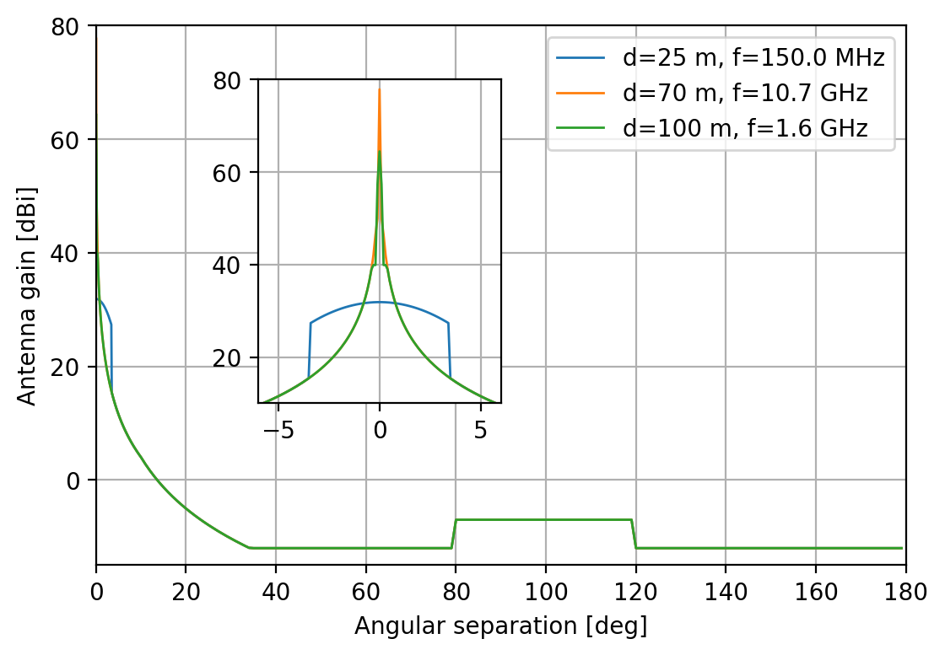
Figure 1: RAS antenna patterns according to Rec. ITU-R RA.1631 for a few example frequencies and antenna diameters.
For the calculation of the aggregated power in a single time step, the antenna diagrams of the transmitting satellite and the RAS station need to be considered. The transmitter patterns can vary a lot depending on the type of the satellites. For the RAS station, it is common to use the pattern as defined in Rec. ITU-R RA.1631, which is displayed in Figure 1 for a few example frequencies and antenna sizes. This pattern is that of a highly idealised paraboloid. There is a noteworthy feature at an angular distance of about 100° from the antenna boresight, which resembles the spill-over ring of the aperture. In reality, RAS antenna patterns are much more complicated, e.g., owing to feed support legs and primary focus cabins, which block part of the aperture. Furthermore, there are also completely different antenna designs in use, in particular for low-frequency interferometers, such as LOFAR or NenuFAR, which employ arrays of dipole antennas that are electronically phased-up to form large synthesised apertures. Still, from a statistical point of view, the results in an epfd simulation are expected to depend mostly on the size of the aperture, which also defines the width of the antenna main beam, thus the RA.1631 model can be considered as suitable in regulatory calculations.
One very important aspect for large satellite constellations is that the power received via the near- and far side-lobes of the RAS antenna play a significant role. For large dish antennas, the main beam gain can be 30 dBi and more above the typical near side-lobe gain (even more compared to far side-lobes). But the chance that a satellite crosses the main beam is low and the sheer number of satellites can produce a significant contribution even via the side-lobes. In Figure 2, a snapshot of a simulation is visualised for three different times, in which the satellites of a large LEO constellation are shown in the topocentric frame (azimuth, $φ,$ and elevation, $ϑ$ of the observer. The antenna pattern is shown as red-shaded area for a case when the antenna points to $\left(φ_{0},ϑ_{0}\right)=\left(31.62°,30.44°\right).$ Again, the spill-over ring appears; as a large area at an angular distance of about 100° from the pointing position.
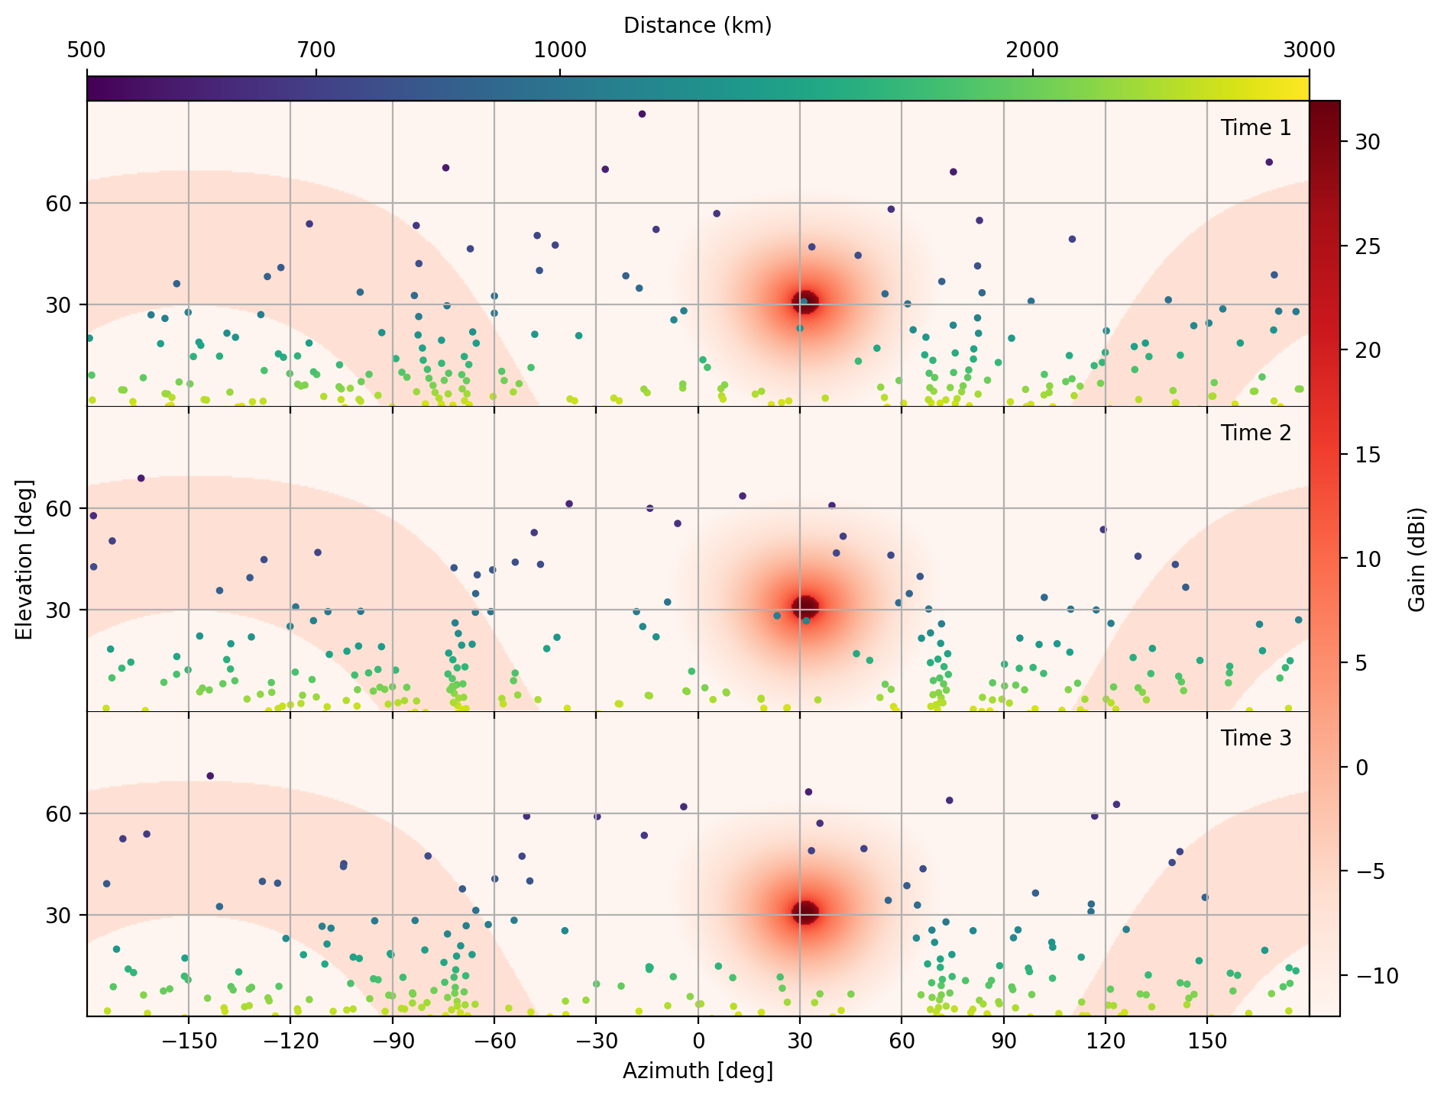
Figure 2: Snapshots of a satellite constellation simulation. The colored circles mark satellite positions and distances in the topocentric (observer) coordinate frame. The red-shaded contours display the RAS antenna gain ($d=25m,f=150MHz$) with the telescope pointing to $\left(φ_{0},ϑ_{0}\right)=\left(31.62°,30.44°\right)$.
For each time step, the resulting aggregated power of all satellite transmissions in the band of interest can then be calculated as
$$P_{rx}\left(φ_{0},ϑ_{0}\right)=\sum_{i=0}^{n}{\frac{c^{2}}{{4πf}^{2}}}{\frac{1}{{4πd}_{i}^{2}}G}_{rx}\left(φ_{i},ϑ_{i};φ_{0},ϑ_{0}\right){G_{tx}\left({\tilde{φ}}_{i},{\tilde{ϑ}}_{i}\right)P}_{tx}.$$ | (1)

Here, the coordinates $\left(\tilde{φ},\tilde{ϑ}\right)$ refer to the antenna coordinate frame of the satellite (each being fixed to each of the individual satellites and thus moving with respect to the Earth or observer frames). Most of the quantities in the above equation are time-dependent and/or depend on the ID of the satellite. The result of this operation is shown in Figure 3 for a time span of 2000 s. The three snapshots of the constellation, which are shown in Figure 2, are marked with vertical red lines. and were chosen to refer to different situations: (1) a satellite crosses very close to the main beam of the RAS telescope and causes a strong peak in the received power levels, (2) one or more satellites are close to the main beam, i.e., in the near side-lobe domain, and (3) the received emission is determined by the far side-lobe contributions.
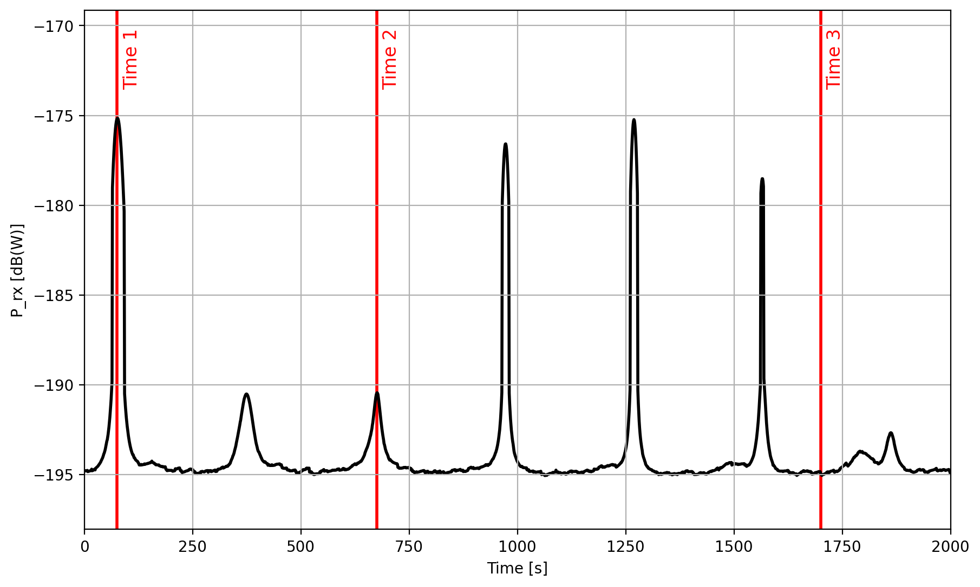
Figure 3: Aggregated received power for an example satellite constellation. The three snapshots of the constellation, which are shown in Figure 2, are marked with vertical red lines.
It is noted that the received power, as defined in Equation (1), is not the quantity, which is used in Recommendations ITU-R S.1586 and ITU-R M.1583 as metric. There, the equivalent-power flux density (epfd)
$${epfd\left(φ_{0},ϑ_{0}\right)=\frac{{4πf}^{2}}{{c^{2}}^{}}\frac{1}{G_{rx}^{max}}P}_{rx}\left(φ_{0},ϑ_{0}\right)=\sum_{i=0}^{n}{\frac{1}{{4πd}_{i}^{2}}}\frac{G_{rx}\left(φ_{i},ϑ_{i};φ_{0},ϑ_{0}\right)}{G_{rx}^{max}}{G_{tx}\left({\tilde{φ}}_{i},{\tilde{ϑ}}_{i}\right)P}_{tx}$$ | (2)
is defined, which is the power flux density (pfd) that a single satellite would have at the RAS station if it were located in the pointing direction of the telescope. However, in practice, one usually converts this number to a 0-dBi reference, because the pdf threshold levels in Rec. ITU-R RA.769 are given for an isotropic receive antenna, i.e., one sets $G_{rx}^{max}=1$. Then the above equation becomes
$${{\left.epfd\left(φ_{0},ϑ_{0}\right)\right|}_{G_{rx}^{max}=1}=\frac{4πf^{2}}{c^{2}}P}_{rx}\left(φ_{0},ϑ_{0}\right)=\sum_{i=0}^{n}{\frac{1}{{4πd}_{i}^{2}}}{{G_{rx}\left(φ_{i},ϑ_{i};φ_{0},ϑ_{0}\right)G}_{tx}\left({\tilde{φ}}_{i},{\tilde{ϑ}}_{i}\right)P}_{tx}.$$ | (3)
The threshold levels in Rec. ITU-R RA.769 are defined for an integration time of 2000 s, which means that the received power (or epfd) has to be averaged over 2000 s of the simulation. Furthermore, Recs. ITU-R S.1586 and ITU-R M.1583 propose to split the sky in cells of equal area and repeat the analysis for random telescope pointings within these cells to assess the spatial distribution of received powers.
Annex 1 of Recommendation ITU-R M.1583 describes a possible scheme to define the sky cells. The size of the cells was chosen to have a fixed solid angle (e.g., 1 or 3 square degrees). When one wants to sample a random position within the cell, $k$, it is important that the overall distribution of telescope pointings stays uniform on the sphere. This can be done by drawing the azimuths from a random uniform distribution, $U$, within the interval $\left[φ_{k}^{low},φ_{k}^{high}\right]$. For the elevations, however, a correction needs to be applied to account for the spherical curvature, hence
$φ_{k} U\left(φ_{k}^{low},φ_{k}^{high}\right)$ ,  $ϑ_{k} 90°−\cos^{−1}U\left(z_{k}^{low},z_{k}^{high}\right)$,  $withz_{k}^{{low}/{high}}=cos\left(90°−ϑ_{k}^{{low}/{high}}\right)$ . | (4)
The simulation should be repeated often enough that the distribution of received powers in each sky cell converges. This repetition also offers the possibility to analyse the typical scatter, e.g., of the mean received power levels in each cell. Furthermore, Rec. ITU-R RA.1513 permits other services to interfere with the RAS for 2% of the time. The statistical distributions resulting from iterated simulations allows to determine such percentiles (2% of data loss refer to 98% percentile of the received power level, which then must not exceed the RA.769 thresholds).
- In the paragraph below, add examples of both interpretations of the criterion.
Unfortunately, it is not well laid out, how exactly the 2% criterion is to be understood. One interpretation could be to calculate the 98% percentile level of the received aggregated pfds over the full sky and compare that number to the threshold value given in RA.769 (hereafter called total data loss). Other studies in ECC (e.g., in ECC Report 247 and references therein) count the number of sky cells in which the average pfd is larger than the RAS threshold and relate that to the total number of cells, i.e., no more than 2% of the sky area must be affected.
An additional consideration is the question which reference frame should be assumed for the epfd calculations.
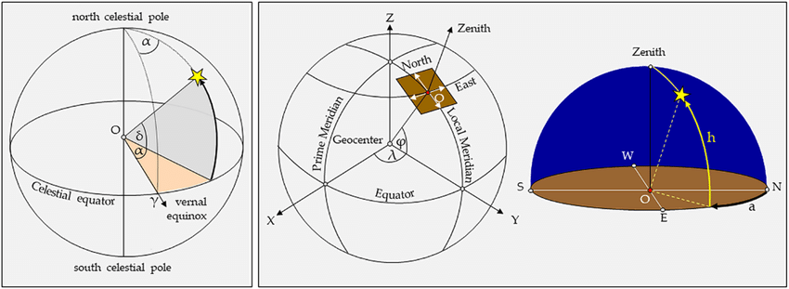
Figure 4: Two common reference systems used in astronomy. Left: the equatorial earth-centered intertial system, which is the most commonly used reference system. The position of an object on the sky is described in a reference frame fixed on the celestial sphere. The position of a (very distant) star is constant with time. It is described by the polar coordinate pair right ascension (abbrev. RA) α and declination (abbrev. Dec) δ. Right: Topocentric system. The position of an object on the sky is described from the viewpoint of the observer using the polar coordinates azimuth a and elevation, or height, h. Image from "Astronomical Investigation to Verify the Calendar Theory of the Nasca Lines" by C. Richter, B. Teichert, K. Pavelka, is licenced under CC BY 4.0.
Figure 4 shows two alternative reference frames used in astronomy. The equatorial inertial system or earth-centered inertial system is fixed on the celestial sky and uses the polar coordinate pair right ascension (abbrev. RA) α and declination (abbrev. Dec) δ to describe the position of an object. The origin for the declination is the celestial equator (great circle with 90° distance from the North- or South pole), while the origin for the right ascension is given by the position of the sun on the equator at the vernal equinox. Since this inertial system changes slightly with time, a reference time has to be specified with the coordinates, mostly chosen to be the year 2000 (J2000). The equatorial system is the most commonly used reference frame in astronomy, since the coordinates of most objects on the sky are constant or change very slightly.
The topocentric rest frame describes the position of an object from the perspective of the observer, using the polar coordinates azimuth a and elevation or height h. The height of an object is the angle with respect to the horizon (great circle at 90° separation with respect to the zenith or upwards direction), while the azimuth is the angle between the local meridian (North or South direction) and the position of the object.
Recommendation ITU-R M.1583 does not explicitly prescribe the usage of a topocentric reference system. The usage of azimuth and elevation, however, suggests the topocentric coordinate system as a basis for the data loss calculations. In practice, however, the pointing directions in astronomical observations are often not constant with respect to an earth-fixed system, but they are rather constant with respect to an earth-centered inertial system. In other words, radio telescopes often track observed objects on the sky rather than pointing to a fixed direction with respect to the earth's surface. This is the case if a certain astronomical object is being observed. Opposed to that, observing modes with fixed directions in the topocentric system are used when mapping large areas of the sky. As a consequence, only if both situations are simulated, the result covers all fundamental cases in RAS operation.
We hence also include epfd calculations in which the reference system is an earth-centered inertial system with the (celestial) coordinates right ascension α and declination δ. The accessible latitude (declination) ranges depend on the geographical latitude φ of the observatory. In the northern hemisphere the range is 90° < δ < φ - 90° and in the southern hemisphere -90° < δ < φ + 90°. epfd calculations hence have to take a larger range of coordinates into account.

Use of PFD masks for method
The power flux density (PFD) produced on the Earth's surface by a satellite is computed as following:

Equation (X)

Considering Equations (X) above and equation (3) of paragraph 5.1.2, we would obtain:

Equation (Y)

PFD masks are given as an attachment to the data provided by an administration notifying a non-GSO system. Those PFD masks indicate, for each satellite of the constellation, the maximum level of power flux density that it can produce in any direction of propagation.

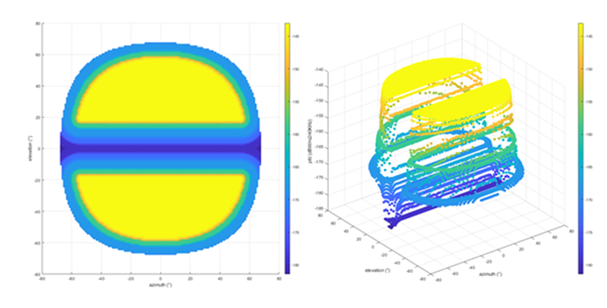
Figure AAA - Illustration of PFD mask as provided by the notifying administration of a non-GSO system

The notified PFD masks could be used for compatibility with RAS studies, because they are representative of the way non-GSO systems are operated, even if that would be a conservative approach (PFD masks indicate the maximum potential radiated flux in a given direction).
However they cannot be directly used for the EPFD computation, additional parameters are needed.

- Attenuation due to Out of band aspect
Since the non-GSO systems that could generate interference to radio telescope operate in the space-to-earth direction in bandwidths that are adjacent to the ones allocated to the radio astronomy service, a certain attenuation factor is to be taken into account.
This attenuation value can be determined using the information on the out-of-band characteristics of the output section (Amplification stage, filtering, antenna) of the non-GSO satellite, if available, or computed with an appropriate recommendation (e.g. ITU-R SM.1541)

- Selection of the "Nco" satellites pointing directly towards the RAS site
In line with the information provided by the notifying administration of the non-GSO system, the quantity of satellites transmitting towards a given area on Earth’s surface at the same time is determined by the “Nco” parameter (parameter A.4.b.7.a of Appendix4). The difficulty is to know, at each moment, which ones are those Nco satellites out of the entire constellation. They can be any of the non-GSO satellites which are simultaneously in visibility of the radio astronomy site and outside of the GSO avoidance arc.

- Contribution of non-GSO satellite not pointing towards the radio astronomy telescope site
The interfering non-GSO satellites are all the non-GSO satellites that are in visibility of the radio astronomy site. Among those satellites, as said previously, “Nco” satellites will be emitting in direction of non-GSO earth stations co-located with the radio astronomy site, and the rest of the non-GSO satellites will be transmitting towards other locations on Earth. Still, those satellites can generate interference to the RAS due to their sidelobe emissions. To determine those levels of emission, it is necessary to compute the off-axis gain (Tx) between the direction of the earth station with which the non-GSO satellite is communicating and the direction of the radio astronomy site. To compute this off-axis value, the antenna pattern (Tx) of the non-GSO satellite would be needed, because, unfortunately, the Recommendation UIT-R S.1528 describing reference antenna pattern for non-GSO system is representative only of systems using parabolic antennas.

Total data loss
- It is understood that the full simulation is the prefered methodology, other methodologies are evaluated to see if simpler analysis would be easier to implement while still achieving the same results
The above approach can in principle easily be extended to incorporate more than one satellite constellation, to determine the total data loss caused by all constellations together. The sum in Equations (1) to (3) makes no difference on the type of satellite. The only difficulty could be that the memory of the compute might not suffice to hold all values at the same time − the problem space can become very large as the contributions to the received power depends on the combination of all sky cells with all satellite positions over hundreds or thousands of time steps; and all of this is repeated a number of times. However, it is straight-forward to do the simulations in batches and store intermediate results on disk for the final analysis.
The total data loss (independent on what data loss metric is used) is not necessarily a simple linear sum of the data losses caused by individual constellations. This is owing to the fact that the distribution of satellites on the sky can differ significantly, e.g., with respect to orbit altitudes or inclinations. As this has impact on the distribution and distances of the satellites in the topocentric observer frame, it could be that two very distinct constellations with 2% data loss each, won't cause 4% together. It is, however, obvious, that the overall data loss cannot be smaller than the larger data loss value of the individual constellations and that it must be smaller (or equal) than the simple sum of each of the data losses.
- The last statement above needs to be reviewed
The aim of this report is also, to analyse the various constellation types and parameters and what impact they have on the data loss summation.

Full simulation
The methodology developed 5.1may be applied to assess the aggregated data loss, by the aggregated epfd from all NGSO systems and applying the aggregated protection threshold.

The example given in this subsection illustrates the potential consequences in term of EPFD exceedance when considering more than one constellation.
To do so, we assessed the respective impact in term of data loss and affected sky cells for two non-GSO constellations independently, then altogether.

The first constellation for which the analysis has been done has the following main characteristics:
- 22 orbital planes with ascending nodes evenly distributed
- In each plane, 22 satellites equally spaced
- Orbital inclination of 55°
- Satellite altitude of 500km
- Transmitted Power of -44dBmW
- Isotropic antenna

the sky cells that can be considered as corrupted (meaning that more than 2% of the epfd samples have a value over the threshold of -180dBW/m2) with the first constellation.

Figure WW- constellation 1 - Sky cells with more than 2% of samples with epfd>-180dBW/m2
98 cells are affected by constellation1, and the data loss is 1.4% as shown in the CCDF below:

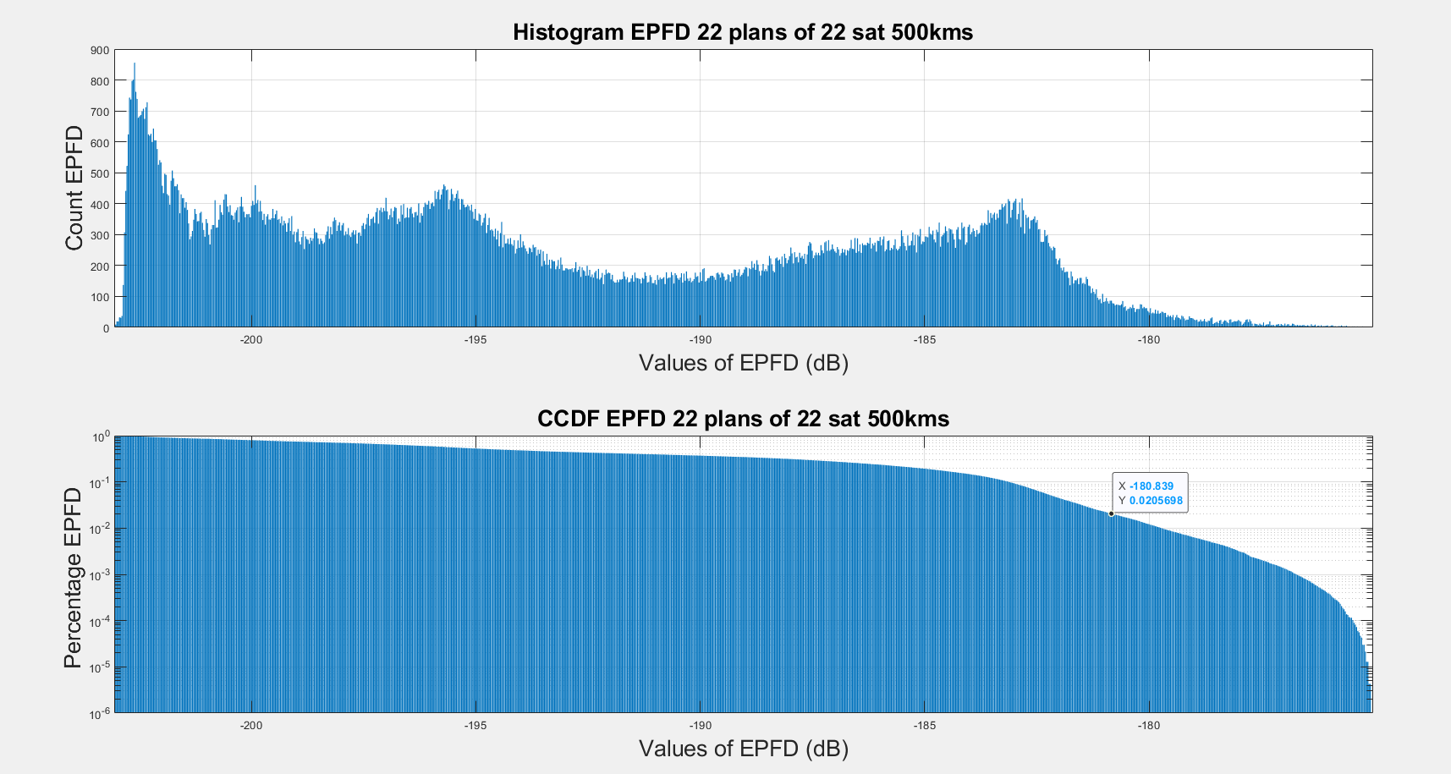
Figure WWW- Constellation 1 - Histogram and CCDF of epfd samples for all sky cells

Then, a second constellation is considered, with the following parameters:
- 22 orbital planes with ascending nodes evenly distributed
- In each plane, 22 satellites equally spaced
- Orbital inclination of 30°
- Satellite altitude of 1000km
- Transmitted Power of -38dBmW
- Isotropic antenna

This second constellation has an impact on the RAS, with a exceedance of the EPFD threshold for more than 2% of the samples in the following sky cells:

Figure XX- Second constellation - Sky cells with more than 2% of samples with epfd>-180dBW/m2
118 cells are affected with constellation 2, and the data loss is 2.4% as shown in the CCDF below:
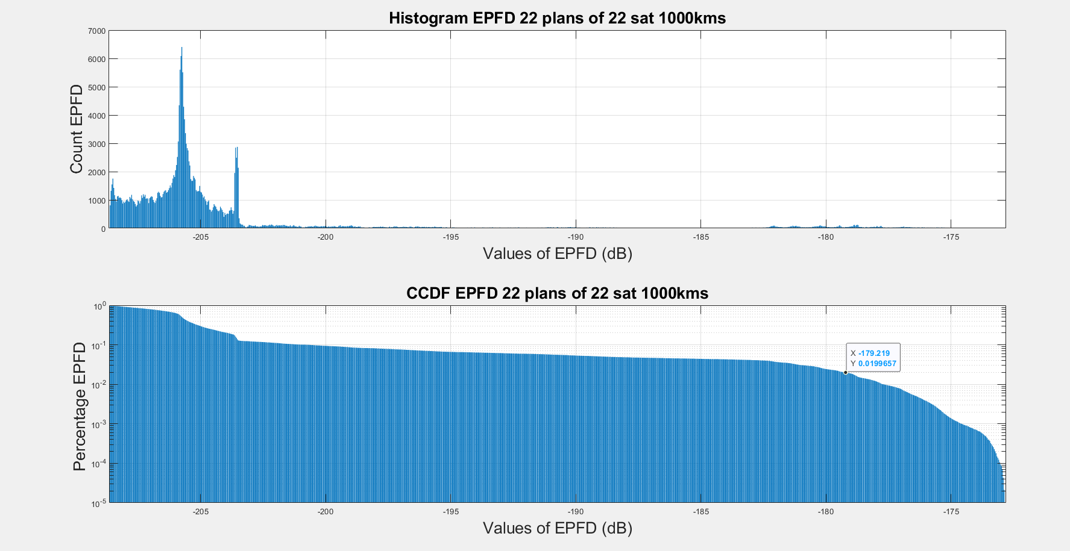
Figure XXX- Constellation 2 - Histogram and CCDF of epfd samples for all sky cells
It is worth to note that the set of sky cells affected respectively by the first (98 cells) and the second (118 cells) constellations are independent.

A third simulation is run with the 2 constellations operating simultaneously, the affected cells are shown below:
Figure YY - Constellations 1 & 2 -Sky cells with more than 2% of samples with epfd>-180dBW/m2
With the two example constellations operating simultaneously, we have now 220 sky cells showing exceedance of the EPFD threshold for more than 2% of the samples.
The Data loss is also computed for those 2 constellations and reaches 4.1% as it can be seen on the CCDF below:

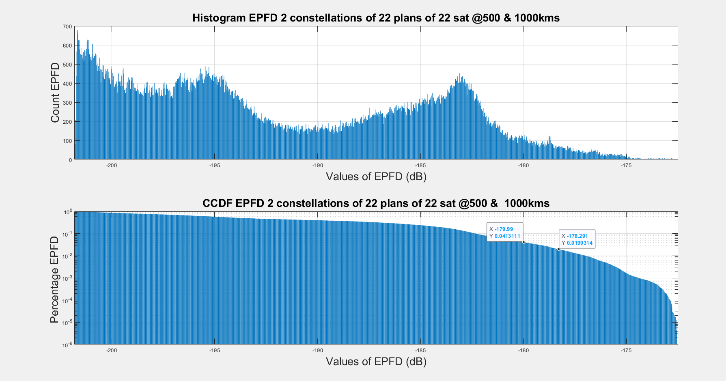
Figure YYY- Constellations 1 & 2 -Histogram and CCDF of epfd samples for all sky cells

FigureZZ - Summary of the simulation results
It can be concluded that neither the data loss nor the quantity of affected cells when considering more than one constellation can be obtained through the simple addition of those constellations single entry simulation results.

Linear sum of individual data losses
- With this we mean the simple addition of the individual data loss percentages. It could be studied, under what circumstances the linear sum is close to the truth (or not), depending e.g. on orbital parameters of the constellations

Analytic approximation

[Others]

Conclusions

Sensitivity analysis on the influence of the satellite parameters on the aggregated data loss
- In the following, the github WWW address should be possibly be replaced by a software package attached to the document.

The calculations in the consecutive Sections have been carried out using a Python script in the form of a Jupyter notebook, making use the pycraf and cysgp4 software packages. The software can be accessed through a GitHub repository with the URL https://github.com/gigjozsa/SE40_45_pycraf_scripts

Sensitivity analysis for single entry cases
An application of the method laid out in Section 5.1 is demonstrated again with the configuration defined in Section 5.1.1., which serves as a reference configuration in the following relative calculations, throughout in Section 6. We use a configuration of 484 satellites, distributed into 22 orbital planes with ascending nodes evenly distributed, and 22 satellites per plane equally spaced in their circular orbits. The satellite altitude is 500 km above the ground, the orbital inclination is 55°. We assume an isotropic antenna pattern for each satellite (G = 0 dBi). Further, the RAS frequency is set 1413.5 MHz, which is in the middle of an important RAS passive band (1400−1427 MHz). We choose a value for the transmitted power of −44 dB[mW] over the 27 MHz bandwidth, which leads to a total data loss in the order of one percent. This will allow us to study the change of the data loss with constellation parameters around the value of interest. The telescope diameter is 25 m and its geographic latitude is 50° N. The grid in the topocentric calculations is chosen to have a cell size of approximately 3°x3° on average starting at an elevation of 0°, resulting in a number of 2292 cells. The reason for the difference between the number of cells in our calculations and Recs. ITU-R M.1583 and ITU-R M.1586, which cite 2334 cells for the same setup, is different rounding methods when calculating the cell size in azimuthal direction. Our calculations rely strictly on the formulas given in Recs. ITU-R M.1583 and ITU-R M.1586, allowing for an arbitrary value for the size of the cells in azimuthal direction, while in the example in Recs. ITU-R M.1583 and ITU-R M.1586 the rounding condition is that the cell sizes in azimuthal direction have an integer value in units of degrees. To achieve the goal for similar solid angles in the cells, the method used here is more accurate. In Section 5.2.1, the example sectorisation in Recs. ITU-R M.1583 and ITU-R M.1586 was used, which leads to slightly different results. The grid in the equatorial reference frame is chosen to have a cell size of approximately 3°x3° on average starting at a declination of -40°, resulting in a number of 3438 3709 cells. The experiment is repeated 100 times with different starting times, each simulation runs over 2000 s with a time resolution of 1 s. As a result we obtain 100 simulated epfd samples per cell. These can be compared to the power flux density level of -180 dB[W/m2] (Recommendation ITU-R RA.769). Figure 5 shows the average power flux density per cell.

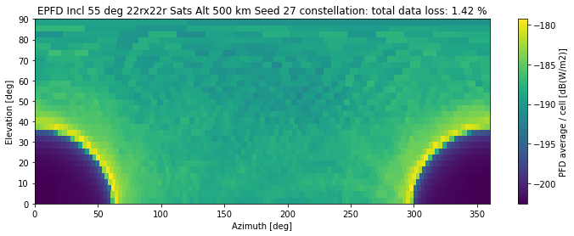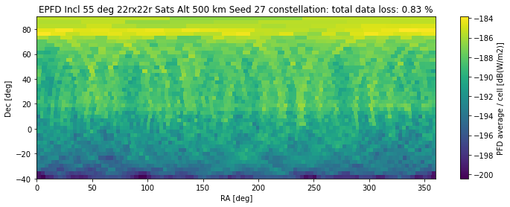

Figure 5: Aggregated received power for an example satellite constellation. Average epfd per cell. Top: topocentric reference frame. Bottom: inertial equatorial reference frame.
For each cell, there are 100 simulations of the epfd, for which the data loss can be calculated as the number of simulations for which the epfd level lies above the one recommended in Recommendation ITU-R RA.769 divided by the total number of simulation runs. This is shown in Figure 6.
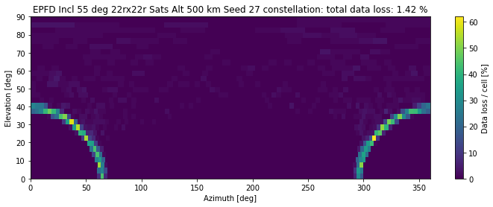
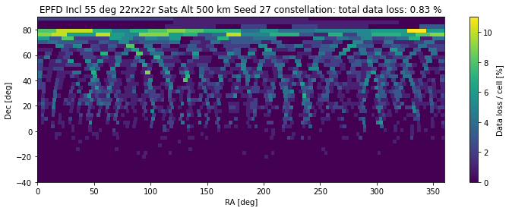
Figure 6: Data loss per cell for an example satellite configuration (as shown in Figure 5). Top: topocentric reference frame. Bottom: inertial equatorial reference frame.
It is also possible to use all 100 simulations to generate a linear plot of the cumulative probability of the epfd to lie above a certain threshold, as shown in Figure 7. This is a common approach used for the decision whether a certain satellite constellation has an acceptable level of data loss for the RAS. The metric used here is the total statistical data loss as calculated for all samples of the time-averaged received power, regardless of position. In contrast, as discussed in Section 5.2, alternative interpretations of the data loss exist. For example, one could argue that in not more than 2% of the sky cells the RAS limits should be exceeded (average epfd per cell over all iterations, compare Fig. 4). As explained in Section 5.1, most astronomical objects are fixed in the equatorial frame. To guarantee a successful observation of any of these sources, even in a single sky cell the data loss should not be exceeded for more than 2% of the time (see Fig. 5, bottom panel). It should be noted that in rare cases observations are performed in the so-called drift-scan mode, in which the telescope is observing a fixed position relative to the earth (see Section 5.1). Under these circumstances the data loss in a given topocentric cell is relevant. However, the possibility exists to point the telescope to a topocentric position that is less affected. This is not possible for an observation pointed to a position in the equatorial frame.

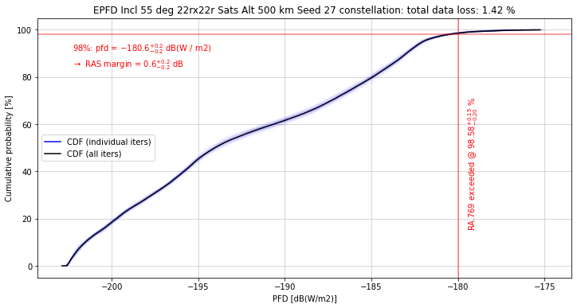
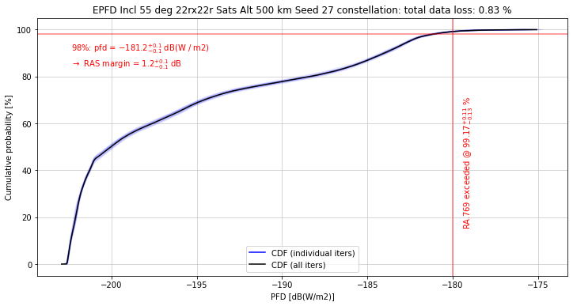
Figure 7: Cumulative probability for a cell exceeding a given power flux density. Central solid line: for all simulations and every cell. Light blue lines close to solid line: per simulation for all cells. The Recommendation ITU RA.769 threshold of an epfd of −180 dB[W/m2] is exceeded at a level of 98.6%, while 98% would be reached at a epfd level of −180.6 dB[W/m2]. The so-called RAS margin is 0.6 dB dB[W/m2]. Bottom panel: inertial equatorial reference frame: the Recommendation ITU RA.769 threshold of an epfd of −180 dB[W/m2] is exceeded at a level of 99.2%, while 98% would be reached at a epfd level of −181.2 dB[W/m2]. The so-called RAS margin is 1.2 dB dB[W/m2].

However, it is evident that in all these calculations the statistical data loss is a secondary quantity that is determined from a set of simulations. While the data loss per cell or for the complete set of simulations does not add linearly for two constellations, the average epfd does, provided it is determined based on a sufficient number of simulations.
To study the effect of the change of single configuration parameters, we first generate the average epfd distribution on the sky for a reference configuration, to then change single parameters of the reference configuration and study the effect by calculating the ratio of the epfd per cell on the sky grid. For the reference configuration we use the same parameters as in above example.

Orbital parameters
We calculate the change of the average power flux density as a function of the orbital inclination. Figure 8 and Figure 9 show the ratios of the average power flux densities per cell for a few selected orbital inclinations and the reference configuration (orbital inclination of 55°) as displayed in Figure 5.
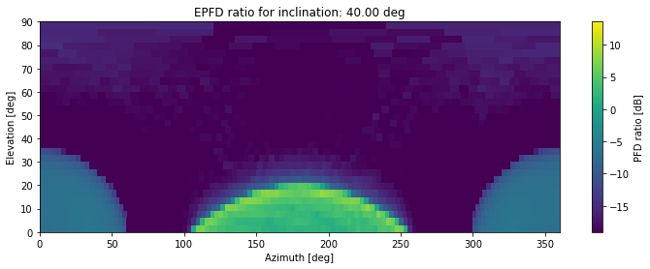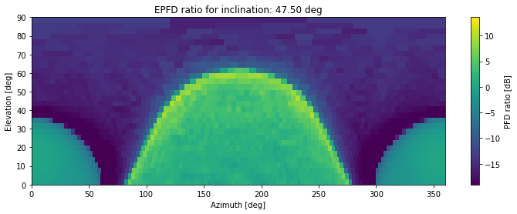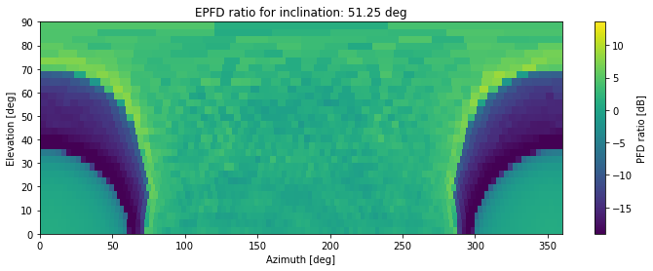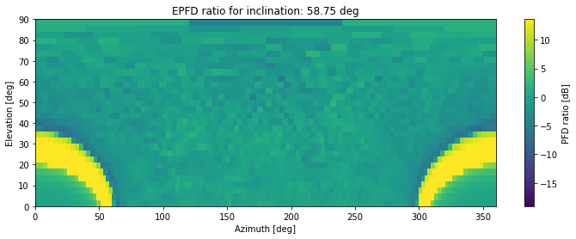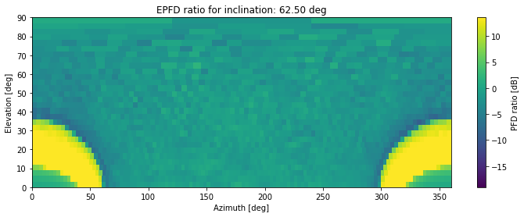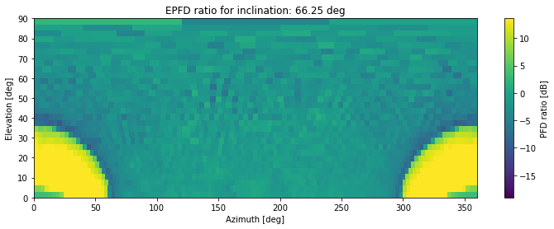
Figure 8: Ratio of epfd of a configuration changing in orbital inclination and a reference configuration (orbital inclination 55°), topocentric reference frame.

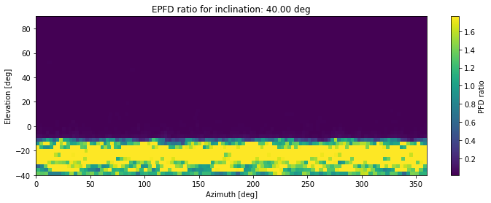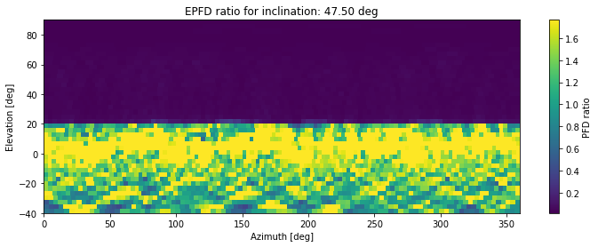
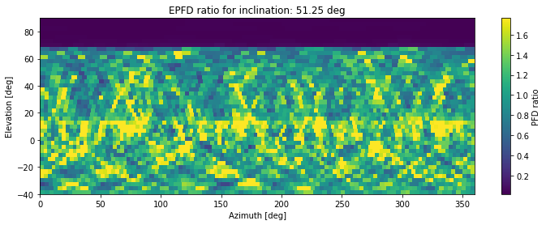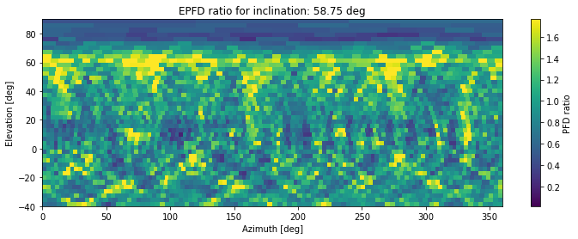
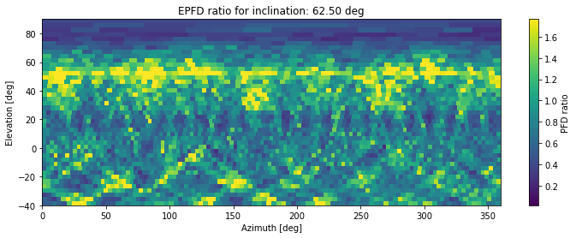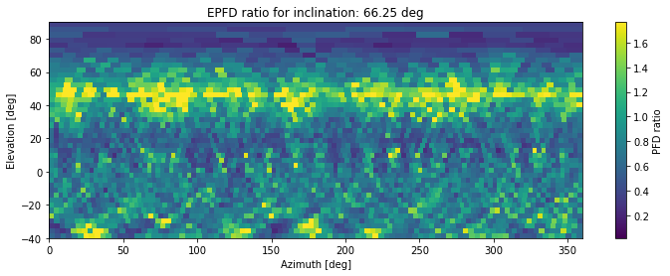
Figure 9: Ratio of epfd of a configuration changing in orbital inclination and a reference configuration (orbital inclination 55°), inertial equatorial reference frame.

Since the altitude of the satellites is low (500 km) the position of the satellites on the sky never reaches the zenith, if the orbital inclination is much lower than the geographic latitude of the observatory. This only happens at an orbital inclination a few degrees below the geographic latitude of the RAS station. Above the value of the orbital inclination, the changes in the epfd ratio are significantly lower. Building the 5% and 95%-percentile of each plot shown in Figure 8, as well as the mean and standard deviation of the cell values, one generates a linear plot of epfd statistics with inclination. This is shown in Figure 10.
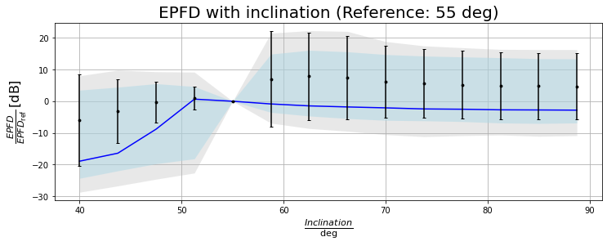
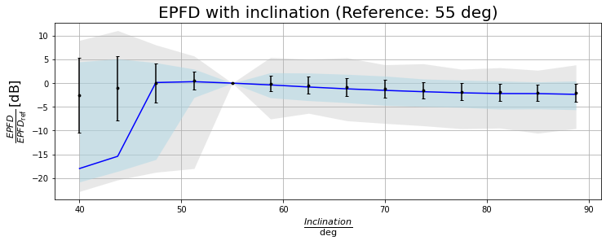

Figure 10: Ratio of epfd of a configuration changing in orbital inclination and a reference configuration (orbital inclination 55°). Black dots and error bars show the average and standard deviation. The blue shaded area comprises the area between the 5% percentile and the 95% percentile, the grey shaded area is the area between minimum and maximum in the plot. Top: topocentric reference frame. Bottom: inertial equatorial reference frame.
Figure 10 reflects the tendency observed in the single plots: above an orbital inclination slightly below the geographic latitude of the RAS station, the epfd rises quickly as the satellites become visible at all elevations and then approximately saturates at a certain value above the geographic latitude of the RAS station.
Already these viewgraphs show the effect of taking the inertial system into account for the epfd calculations: the equivalent power flux density is more evenly distributed over the sky.
The next parameter that is changed is the satellite altitude. Error: Reference source not found shows the epfd ratios for two exemplary altitudes and the statistical plot in the topocentric rest frame, Figure 12 shows the same quantities in the equatorial frame. As expected, as the power flux density decreases quadratically with distance, this is a monotonic function. As however also the visibility of the satellites changes, the precise shape of the dependency remains to be studied in greater detail.

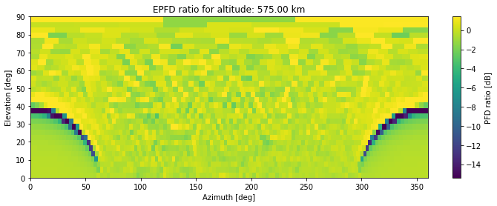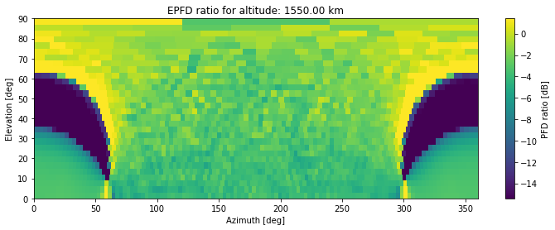
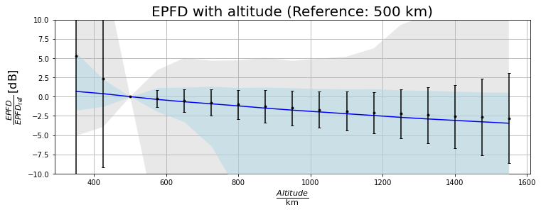

Figure 11: Ratio of epfd of a configuration changing in altitude and a reference configuration (altitude 500km), topocentric reference frame. Top: per cell for two altitudes. Bottom: averaged over cells. Black dots and error bars show the average and standard deviation. The blue shaded area comprises the area between the 5% percentile and the 95% percentile, the grey shaded area is the area between minimum and maximum in the plot.

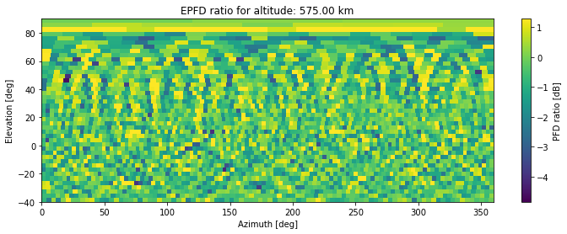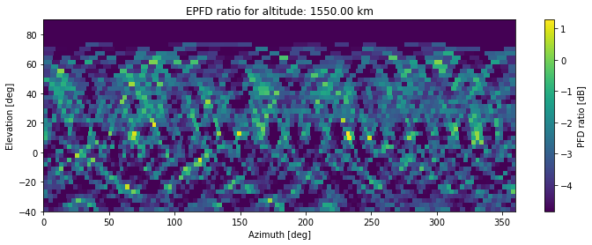

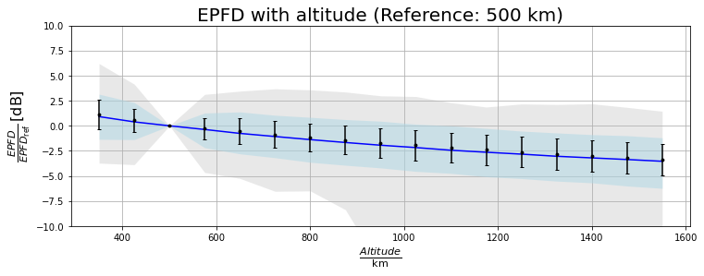

Figure 12: Ratio of epfd of a configuration changing in altitude and a reference configuration (altitude 500 km), inertial equatorial reference frame. Top: per cell for two altitudes. Bottom: averaged over cells. Black dots and error bars show the average and standard deviation. The blue shaded area comprises the area between the 5% percentile and the 95% percentile, the grey shaded area is the area between minimum and maximum in the plot.

Number and distribution of satellites per constellation
In the next set of simulations we choose the number of orbital planes to be approximately equal to the number of satellites per plane and increase the total number of satellites. This results in a nearly perfectly linear dependency: the epfd can be assumed to be proportional to the number of satellites if no other parameter is changed; see Figure 13.
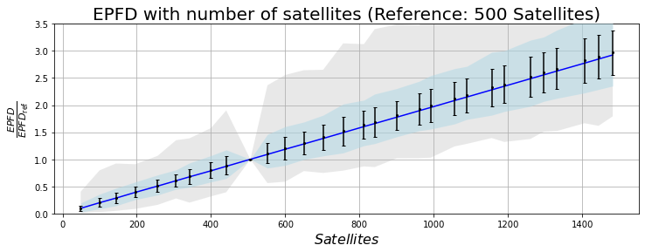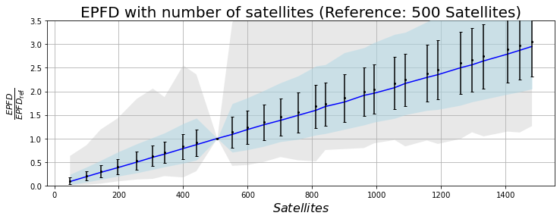
Figure 13: Ratio of epfd of a configuration changing in the number of satellites and a reference configuration (484 satellites). Black dots and error bars show the average and standard deviation. The blue shaded area comprises the area between the 5% percentile and the 95% percentile, the grey shaded area is the area between minimum and maximum in the plot. Notice that this plot is linear and not logarithmic, to show the linear shape of the dependency. Top: topocentric rest frame. Bottom: equatorial rest frame.

Antenna patterns of satellites

Transmission parameters and duty cycles

Size and sensitivity of RAS antenna
As a final set of parameters we change the size of the RAS antennas. In addition to the sensitivity this means that the antenna pattern becomes narrower. The consequence of this is visible in Figure 14. With increasing telescope diameter the scatter of the cell values varies as a consequence of the much narrower beam. The epfd becomes much more stochastic. In addition, the average epfd increases slightly with telescope diameter, but while this is a clear trend the gradient is rather low. The epfd ratio between an antenna with a diameter of 300 m and an antenna of 25 m is lower than 1.25.
- This requires some discussion: while it can be expected that with an increased number of repetitions of the experiment the stochasticity of the results can be reduced, these results reflect the expected behaviour of the rfi situation in a real observation. Should we discuss this in the text?
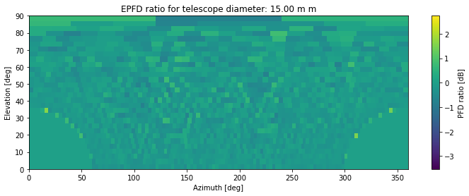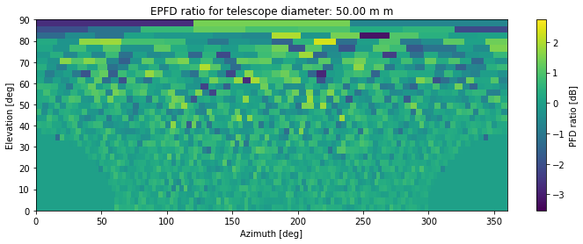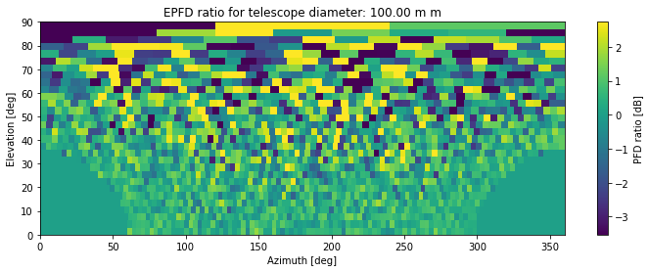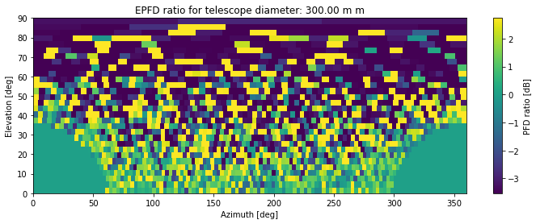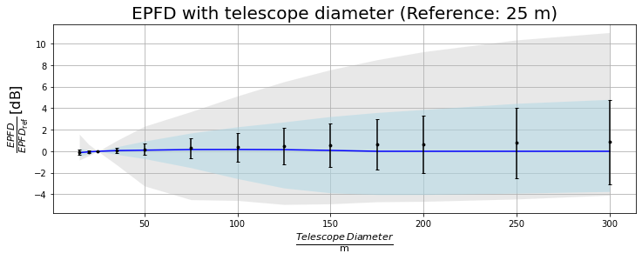
Figure 14: Ratio of epfd of a configuration changing in telescope diameter and a reference configuration (telescope diameter 25 m), topocentric rest frame. Top and middle panels: per cell. Bottom: statistics over cells. Black dots and error bars show the average and standard deviation. The blue shaded area comprises the area between the 5% percentile and the 95% percentile, the grey shaded area is the area between minimum and maximum in the plot. Notice that this plot is linear and not logarithmic, to show the linear shape of the dependency.
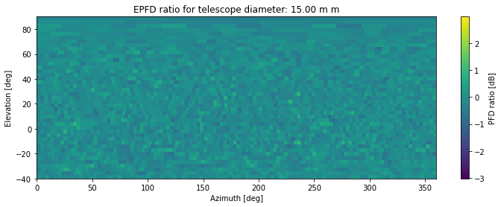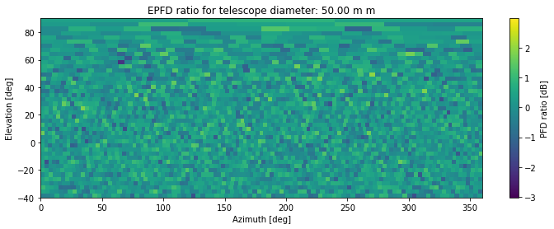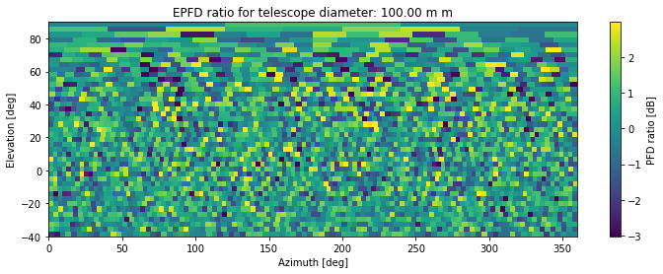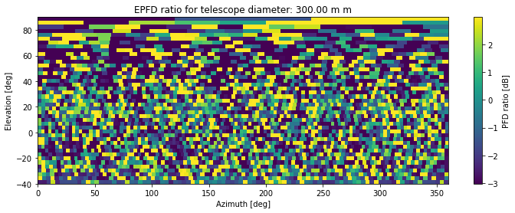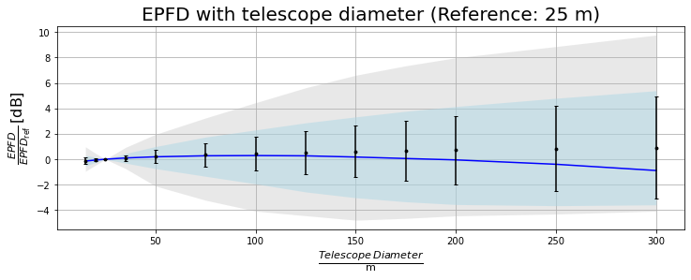
Figure 14: Ratio of epfd of a configuration changing in telescope diameter and a reference configuration (telescope diameter 25 m), equatorial intertial rest frame. Top and middle panels: per cell. Bottom: statistics over cells. Black dots and error bars show the average and standard deviation. The blue shaded area comprises the area between the 5% percentile and the 95% percentile, the grey shaded area is the area between minimum and maximum in the plot. Notice that this plot is linear and not logarithmic, to show the linear shape of the dependency.

Influence of parameters for the aggregated data loss

Orbital parameters

Number and distribution of satellites per constellation

Antenna patterns of satellites

Transmission parameters and duty cycles

Size and sensitivity of RAS antenna

Computation when parameters are missing

Estimation of missing parameters
[Ways to estimate the missing parameters, possibly based on comparison with other systems, or on maximum/minimum value to protect RAS, or on other]

Some worst-case assumptions are taken for some parameters:
- Duty Cycle / Activity Factor: by default it is assumed that the satellites of the non-GSO constellation are continuously transmitting, meaning that the activity factor is 100%.
- Frequency re-use scheme: it is assumed that all satellites of the non-GSO constellation are transmitting signal in the portion of bandwidth directly adjacent to the RAS service.
- Tracking strategy: When considering the Nco parameter in the EPFD computation, the satellite(s) transmitting in the direction of the RAS site are supposed to be the ones closest to the pointing direction of the RAS telescope.
- …
- [List to be continued]

Impact on the total data loss
[Example cases]

Impact of non-GSO constellation operational parameters

When performing EPFD computation for non-GSO constellations, one could argue that some non-GSO operational parameters are to be taken into account, such as, but not limited to,
the actual antenna patterns (either from a recommendation or submitted by the notifying administration of the non-GSO satellite system), Nco, alpha angle, minimum elevation angle, duty cycle, the number of visible satellites from the RAS site….
Some of those parameters can be found in the data provided to ITU-R by the notifying administration of the non-GSO system (precisely in Appendix4), and their id is provided in the table below.

Non-GSO operational parameter description | Details | Filing parameter ? | Parameter name in Appendix 4 data | Parameter units | Parameter id in filing information provided by notifying administration
PFD mask |  | Not directly in Filing database, attached separately |  | dBW/m2/Ref_bw
Non-GSO Tx Antenna Pattern |  | Not mandatory (overtaken by PFD mask in bands where Art. 22 applies) |  | dB for pattern, dBi for maximum gain | -B3c1 antenna radiation pattern  -B3a1 maximum gain
Maximum number of non-GSO satellites operating co-frequency at latitude [lat] | Indicates the maximum quantity of satellites that can transmit signal over a given area on earth's surface | Yes | Nco [latitude] | Alphanumeric value | A.4.b.7.a
Minimum elevation angle | Specifies the minimum elevation angle under which an earth station cannot connect to a given non-GSO satellite. | Yes | ES_MINELEV | Degree | A.4.b.7.cbis
GSO exclusion zone | Area on earth in which the non-GSO satellites cannot transmit to protect GSO service | Deduced from the PFD mask(s) | Alpha or X | Degree
Frequency re-use scheme | Specifies the division of the frequency plan accessible to the non-GSO system (ex: 4-color scheme means that the bandwidth is shared in 4 portions) | No
Tracking strategy | Indicates the conditions that a user earth station will follow to connect to the non-GSO satellites | No
Duty Cycle / Activity factor | Specifies the portion of time during which the non-GSO satellites and the associated are transmitting | No

Some of the operational parameters can have an impact, but if they are not made available to the public, (e.g. frequency reuse scheme, the tracking strategy) their modelization will not be taken into account in the EPFD computation. Default values (i.e, worst case) for some of these parameters can be found in section 6.4.

Conclusions

- List of References

- Recommendation ITU-R M.1583: “Interference calculations between non-geostationary mobile-satellite service or radionavigation-satellite service systems and radioastronomy telescope sites”
- Recommendation ITU-R S.1586: “Calculation of unwanted emission levels produced by a non-geostationary fixed-satellite service system at radio astronomy sites”
- Recommendation ITU-R RA.769: “Protection criteria used for radio astronomical measurements”
- Recommendation ITU-R RA.1513: “Levels of data loss to radio astronomy observations and percentage-of-time criteria resulting from degradation by interference for frequency bands allocated to the radio astronomy service on a primary basis”
- Recommendation ITU-R RA.1631: “Reference radio astronomy antenna pattern to be used for compatibility analyses between non-GSO systems and radio astronomy service stations based on the epfd concept”
- Recommendation ITU-R SA.509: “Space research earth station and radio astronomy reference antenna radiation pattern for use in interference calculations, including coordination procedures, for frequencies less than 30 GHz”
- Recommendation ITU-R S.1428: “Reference FSS earth-station radiation patterns for use in interference assessment involving non-GSO satellites in frequency bands between 10.7 GHz and 30 GHz”

Compatibility analysis (inter-service and intra service) for S-PCS below 1 GHz - approved 28 January 2022
As an example within CEPT, the bands 1616 – 1621 MHz and 148 – 149 MHz are not available for MSS use in the United Kingdom
SHARING STUDIES BETWEEN MES AND EXISTING TERRESTRIAL SERVICES
Kinéis raises 100 million euros to build and launch 25 IoT cubesats
Draft ECC report WI SE12
TSAT Globalstar ELaNa-5 Extremely Low-Earth Orbit (ELEO) Satellite
FCC Authorizes Kuiper Satellite Constellation | Federal Communications Commission
Federal Communications Commission FCC 20-102 - Released: July 30, 2020
FCC Grants Kepler Communications Access to US Market | Federal Communications Commission
Application of Kepler Communications Inc. for U.S. Market Access Authority of a Non-Geostationary Satellite Orbit System in Ka- and Ku-band Frequencies
FCC Grants OneWeb U.S. Market Access for Expanded NGSO Constellation | Federal Communications Commission
OneWeb Minisatellite Constellation for Global Internet Service
FCC Ruling on SpaceX Modification, FCC-21-48A1.pdf, April 2021
FCC Doc - Request for Modification of the Authorization for the SpaceX NGSO Satellite System - Released: April 27, 2021
Telesat modifies its constellation 2378318.pdf (fcc.report)
FCC Report - TELESAT LOW EARTH ORBIT NON-GEOSTATIONARY SATELLITE SYSTEM TECHNICAL INFORMATION SUPPLEMENT TO SCHEDULE
https://www.python.org/
https://jupyter.org/
https://bwinkel.github.io/pycraf/
https://bwinkel.github.io/cysgp4/user_manual.html
https://github.com/

