Annex 4 Measurement Campaign (JRC)

A4.1 Test Set up
The tests have been performed radiating both GNSS signals and AS emission within a shielded anechoic chamber, with the scope of assessing the receivers performance in the most possible realistic environment and including the effect of reception antenna. The testing setup, including a benchmark GNSS signal simulator and equipment to generate AS emissions, is shown in Figure 1.
Figure 1
Testing Setup
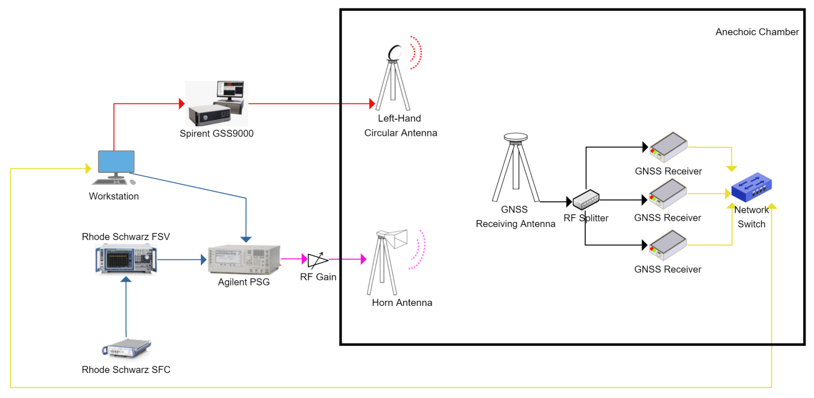
The GNSS simulator and the AS signal generators have been located outside the chamber and connected with two separate transmitting antennas located into the chamber. The Devices under Test (DUTs) and the receiving common GNSS antenna have been located in the anechoic chamber too. All the equipment has been connected through a dedicated LAN and controlled remotely: the test suite has been developed in order to manage automatically batch of tests, including the resetting, logging and monitoring of receivers and signals sources. A post-processing SW suite has been developed to process the logs and carry out the analysis of the identified metrics.
Figure 2
Testing setup within the JRC Ispra EMSL laboratory shielded anechoic chamber
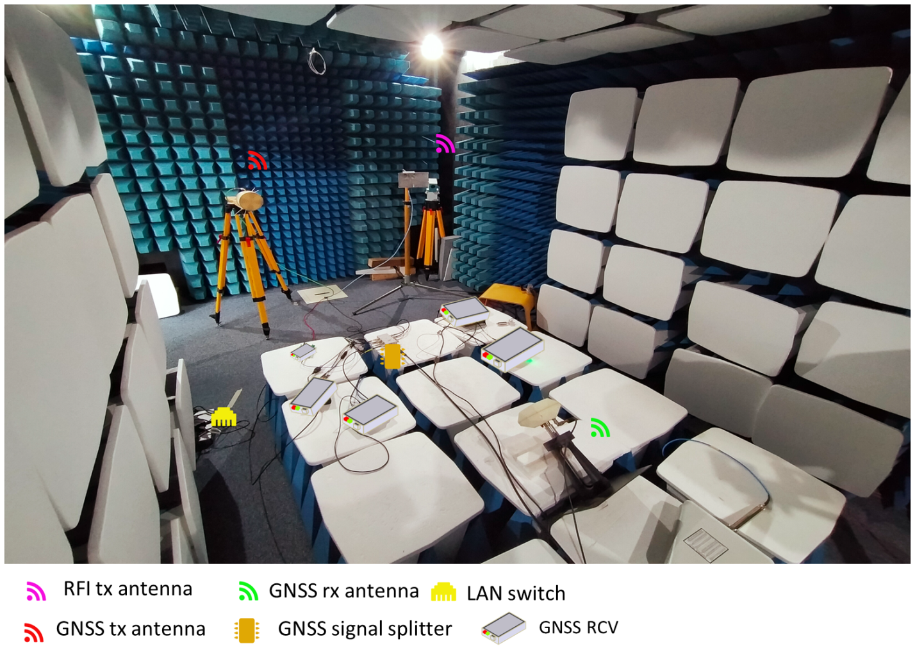
The testing setup, as above described and depicted, included:
– Spirent GSS9000: GNSS simulator used to simulate GNSS signals, including Galileo E6-BC;
– Agilent E8251A PSG signal generator: used as signal generator for the narrow-band Amateur Services emissions. Among others, this device offers the useful capability to load, save and recall specific instrument states in terms of signal type, signal power, signal modulation, centre frequency, and pulsing. In addition, time variations of key parameters such as power level and centre frequency can be programmed and stored in advance.
– Rhode Schwarz SFC compact modulator: used to generate DVB signals
– Rodhe Schwarz FSV Signal Analyzer: used to record the DVB signals to be uploaded in the Agilent PSG.
– High grade GNSS antenna: receiving the entire E6 band.
It is worth mentioning that specific calibration procedures have been executed on the amplification gain of the transmitting chain in order to mimic realistic power receiving conditions of GNSS and AS signals within the anechoic chamber. At this scope, previous measurements of AS emissions in the area (see section 12.2.2) were also used to make sure that the relative power levels were properly considered and fully representative of a real environment.

A.4.2 Test cases
Within this section the different testing cases are resumed, detailing the characteristics of Amateur Services (AS) emissions considered within this testing campaign.

A.4.2.1 AS emissions types
Several AS emission types have been considered within the testing campaign. Those are provided here below classifying them as “Narrow-band” and “Wide-band” following the terms of ITU-R M.1902:
– Narrow-band emissions
• Morse, Bandwidth < 1KHz,
• Narrow Band FM, 15 KHz bandwidth,
• Digital Transmission (dStar), 128 KHz bandwidth,
– Wide-band emissions
• DVBT2 with 1.7 MHz bandwidth
• DVBT2 with 10 MHz bandwidth.

A.4.2.2 AS carrier frequencies
For each of the above listed AS modes, specific carrier frequency as per IARU band plan have been used:
– Morse: 1296.2 MHz
– Narrow Band FM: 1297.5 MHz
– Digital Transmission (dStar): 1299.2 MHz
– DVBT2: 1280 MHz
On top of the above listed frequencies, specific for the different AS modes, the impact of AS emissions transmitted at other possible carrier frequencies within the E6 band have been also tested. As already explained, this is done at the scope of providing the clearest possible picture of the compatibility between the two services within the whole band.
Under this premises, the following frequencies have been tested, all relative to the E6-BC carrier frequency (1278.75 MHz) and expressed in terms of ΔF to such frequency:
– f10: ΔF = 0 MHz
– f12: ΔF = 5.115 MHz
– f18: ΔF = 20.46 MHz
– f19: ΔF = 23.0175 MHz
In the interest of evaluating impact of AS emissions on GNSS receptions, and considering that GNSS signals spectra are symmetric with respect to their carrier frequency, the impact on E6-BC considered at the above frequencies should be considered as representative of the symmetric (with respect to the E6-BC) negative frequency bins (e.g. effect of an interference at “1278.75 MHz + ΔF” will correspond to that of the same interference transmitted at “1278.75 MHz – ΔF”).

{Editor’s note: Further frequency bins are currently under assessment and corresponding results might be added in successive contributions to this document}

A.4.2.3 AS Power Profiles
For each of the AS emission types listed in section 13.2.3.1 and transmitted at each of the centre frequencies provided in 13.2.3.2, the signal has been transmitted at an increasing power level. A power ramp with high increment resolution has been used in order to support the subsequent assessment of C/N0 degradation.
After initial 10 minutes of GNSS-only scenario (AS emission “off”), the interfering AS emission at the specific centre frequency was transmitted with a starting power of -120 dBm (measured at the input of the GNSS antenna) and then incremented of 0.25 dB every 15 seconds. Each test scenario is executed up to -30 dBm.
The power ramp as above described is represented in the following figure.
Figure 3
AS emissions Power ramp
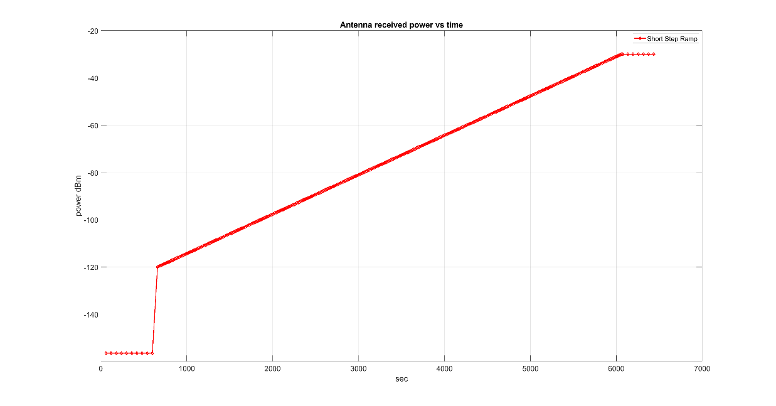

A.4.3 Key performance indicator (KPI)
A commonly accepted indicator for an ongoing interference in the terminology of GNSS is the decrease of the carrier-to-noise density C/N0 at the output of the tracking loop for every single satellite’s signal by 1 dB. Following that, the 1 dB C/N0 degradation has been selected as KPI for this measurement campaign.
C/N0 degradation (vs. interference power [dBm]) was assessed for the three receivers under test, for each AS mode and each carrier frequency under test.
At exemplary scope, a typical output produced for each testing scenario is provided in the following figure. The figure shows the C/N0 degradation for the three receivers under test (referring to a specific testing case) compared with the 1dB degradation threshold.
Figure 4
Exemplary Test result – C/N0 degradation vs. AS emission power
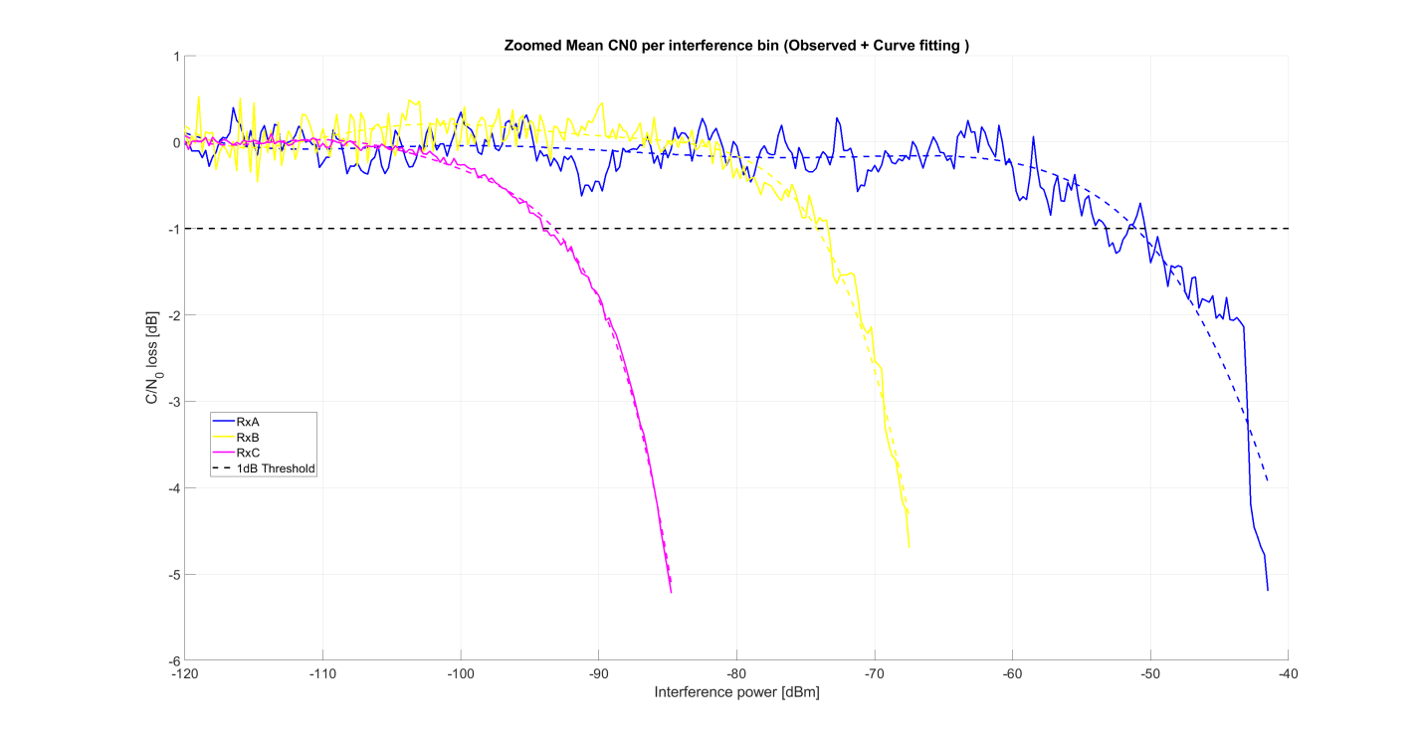

A.4.4 Test results
Within this section a synthetic overview of the obtained results is provided. The results are provided in two separate subsections for the narrow-band and the wide-band AS emissions, respectively. Also, specific results for the IARU band-plan centre frequencies are provided in a dedicated subsection. For each case, the interference power at antenna input leading to 1 dB C/N0 degradation is provided for the three receivers under test campaign.

A.4.4.1 Results for AS Narrow-band emissions
Within this section the results of the assessment for narrow-band AS emissions is provided. For each receiver under test, results are provided for each of the assessed AS centre frequency (expressed as offset from the E6 carrier frequency). The results can be read as an assessment of the tolerance of the receivers under test for the specific AS emission, expressed as a function of its centre frequency.
The results below include the assessment for all the different frequencies under test, including those specific of each AS application as per IARU band plan (identified by full markers).
Figure 5
Test results – Narrow-band AS emissions – Receiver A
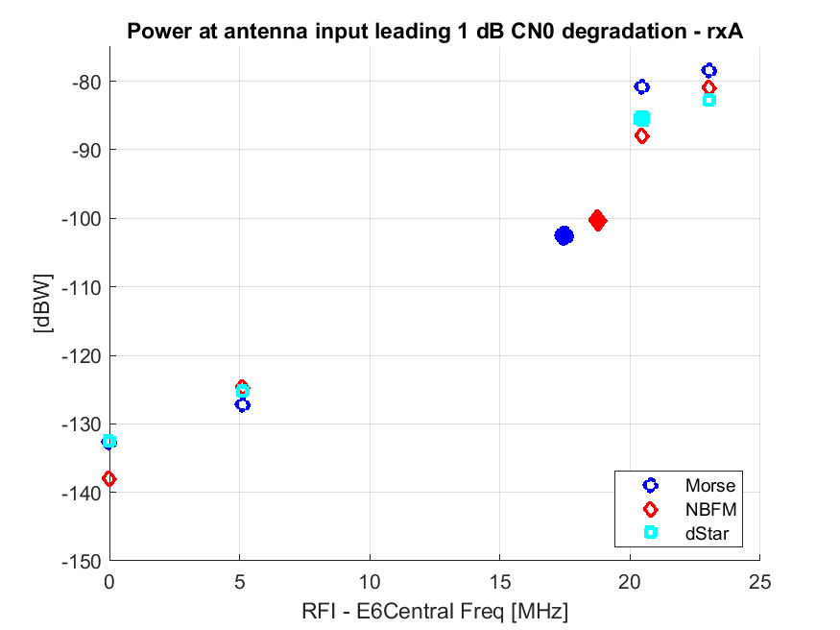

Figure 6
Test results – Narrow-band AS emissions – Receiver B
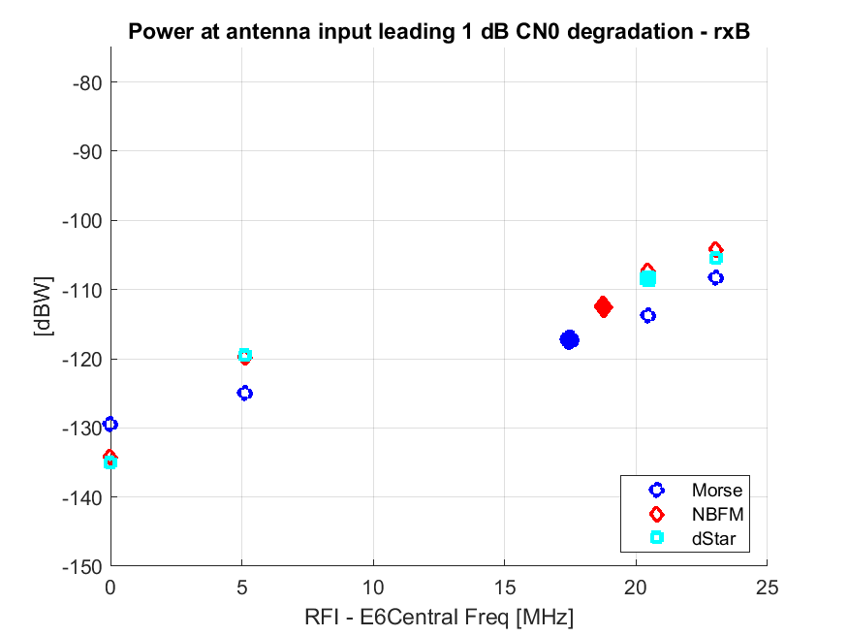
Figure 7
Test results – Narrow-band AS emissions – Receiver C
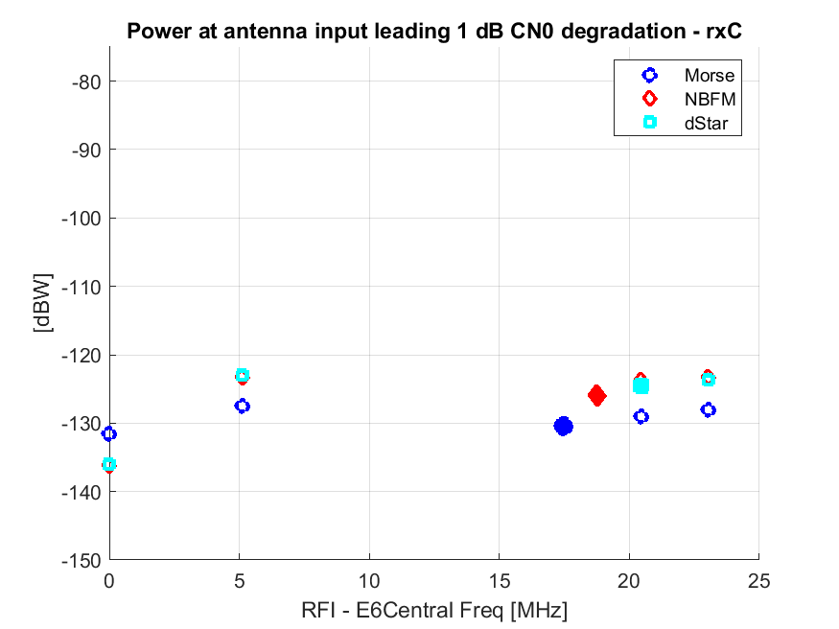

As previously mentioned, the three receivers under test are all high-end professional receivers available in the market, and each of those has specific characteristics, including different RF bandwidth. As one can see, the performance of three receivers is very well aligned when the interfering signal is transmitted “close” to the E6-BC carrier. Going to higher offsets (ΔF>15 MHz), the receivers B and C exhibits a higher sensitivity to the presence of the interference. This is simply because they use a wider front-end bandwidth, which is typically done at the scope of higher performance. Such a wideband use of the E6 band is completely consistent with the RNSS allocation, and some GNSS receivers manufacturers are exploiting it fully.
In general, as expected, it is evident that the receiver C is the one for which Galileo has to seek protection in this specific context, as this is the one exploiting the whole band and as such more vulnerable to AS emissions, especially when they are transmitted farer from the E6 carrier (but still within the E6 band).
It is also worth to mention that, even for receiver C, and especially for certain applications (e.g. NBFM and dStar), the receivers exhibit a substantially higher robustness to AS signals when they are transmitted at higher frequency offsets. For example, in the case of receiver C, a NBFM signal needs to have a 10/15 dB higher power to cause a 1 dB degradation when this is transmitted at ΔF>20 MHz, compared to when this is transmitted at the E6 carrier frequency. This is an encouraging result when seeking for potential compatibility. Still, it is evident that higher power levels would cause an unacceptable degradation to the GNSS receivers.

A.4.4.2 Results for AS Wide-band emissions
Analogously to the previous case, within this section the results of the assessment for wide-band AS emissions are provided. Again, for each receiver, results are provided for each of the assessed carrier frequency (expressed as offset from the E6 carrier frequency). Also in this case, the results below include the assessment for all the different centre frequencies under test, including those specific of each AS application as per IARU band plan. It is to be noted that in the specific case of the 10 MHz wide DVB-T2 emission, the f18 and f19 carrier frequencies have not be tested, as they would lead to an out-of-band emission and therefore not applicable.
Note also that in the case of wideband emissions, the power at antenna input in the following plots is expressed in terms of dBW/MHz.
Figure 8
Test results – Wide-band AS emissions – Receiver A
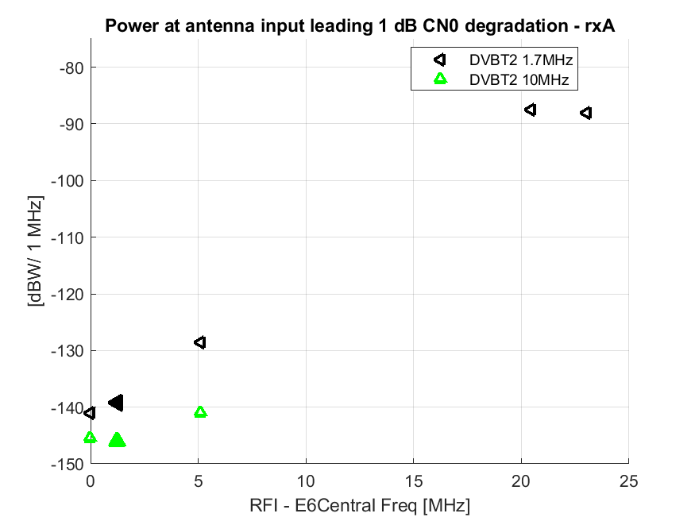
Figure 9
Test results – Wide-band AS emissions – Receiver B
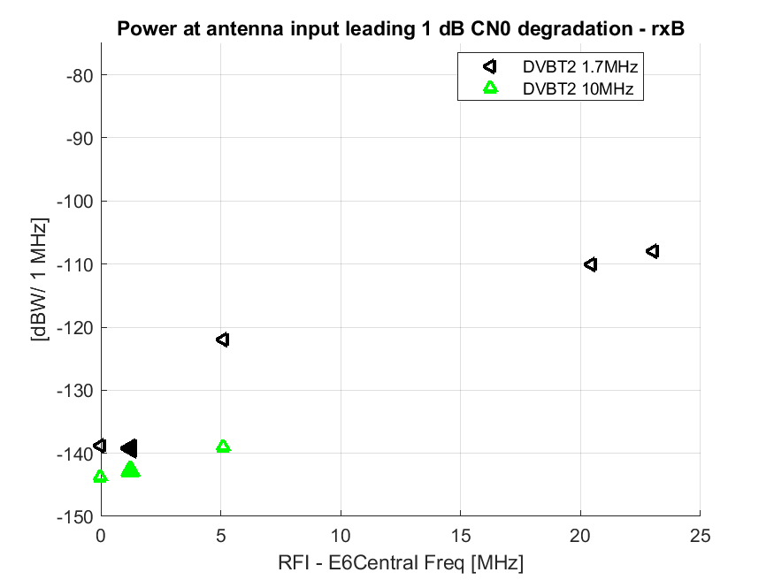
Figure 10
Test results – Wide-band AS emissions – Receiver C
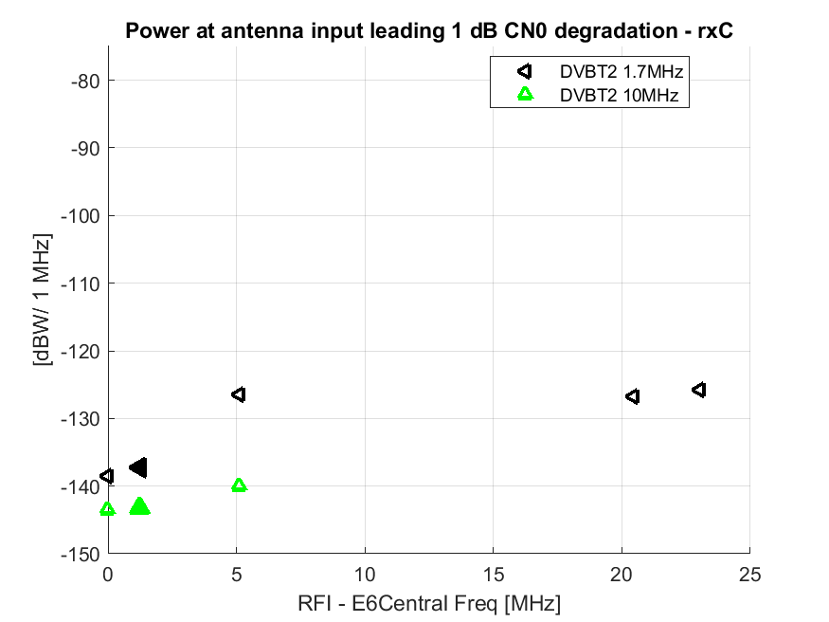
Also in the case of wide band emissions, similar considerations can be done as in the previous case of narrow-band.
Referring specifically to the wide-band case, and as expected, also in this case the receivers exhibit a considerably low tolerance to wide-band interference especially when the emission is close to the E6 carrier frequency. More importantly, it is to be noted that very wide Amateur TV emissions are confirmed to be very critical from a compatibility point of view.

A.4.4.3 Results for the IARU band-plan cases
Specific emphasis is provided here to the results for the specific frequency offsets of the different AS emissions as they are provided in the IARU band plan. Those results are provided here only for receiver C since, as explained before, this is representative of users exploiting the whole E6 band and as such the most impacted by AS emissions in the specific frequencies of interest.

 | Application | Centre Frequency | Bandwidth | Power at antenna input resulting in 1 dB C/N0 degradation
1 | Telegraphy | 1 296.2 MHz | < 1 kHz | -130.5 dBW
3 | NBFM | 1 297.5 MHz | 11.1 kHz | -126 dBW
4 | Digital Data 128 kBit/s | 1 299.2 MHz | 128 kHz | -124.5 dBW
5 | DVB-T2 | 1280.0 MHz | 1 MHz | -137.3 dBW/1 MHz
6 | DVB-T2 | 1 280.0 MHz | 10 MHz | -143.25 dBW/1 MHz

As previously mentioned, out of the IARU band plan, the two services requiring the highest power to cause the 1 dB degradation (and therefore exhibiting the highest compatibility potential) are NBFM and Digital Data.
At the same time, the two Amateur TV wide-band services are impacting the GNSS receiver even with a relatively low power. This suggests a very small compatibility potential within the E6 band. This remains true almost for any of the considered receivers, also considering that the 1280 MHz centre frequency is extremely close to the E6 carrier frequency, and as such the result is almost independent from the specific GNSS receiver bandwidth.
_

