Annex 2 Measurements realized in Germany

A2.1 Methodology and measurement setup
GALILEO E6 was represented by a constellation of ten E6 signals. One signal served as the victim while the other nine were considered as system internal noise, as they are discriminate by the spreading codes within the receiver.
Instead of performing go/no-go tests to a given threshold, the measurements were performed parametrically by applying a wider range of RFI power level while measuring the decrease of the post-correlation C/No of the used GNSS receiver.
The measurement setup is shown in Figure 4. One can see two separate signal paths, one for the GALILEO E6B/C signal and one for the currently tested amateur radio signal. The RFI signals were applied separately, one after the other. Victim and interfering signals from both sides are added at controlled power level and fed into the GNSS receiver.
All receiver input signals are also available to a set of monitoring and measurement equipment (devices 11, 12 and 13). The receiver, like all other active elements in the test set-up, except the RSA (device 11), are interconnected and controlled via LAN. Some test cases include a special Interference Suppression Unit (ISU, device number 24) which is then inserted in front of the GNSS receivers input. Precision step attenuators in both paths enable controlled setting of signal levels. This concept was preferred as it assures reproducible test conditions of the RF power levels. This allowed to compensate the power loss due to the ISU insertion, making sure that the victim receiver is always supplied with the same C/No.
The amateur radio equipment was located in a separate room about 10 m apart from the laboratory hosting the GNSS test set-up. All parts involved in the generation of the amateur radio signals were real life devices (no measurement signal generators involved). All signals were delivered to the main measurements room via high performance coaxial cable to enable unambiguous RF power level conditions at the GNSS receiver input. This separation proofed successfully the rejection of radiation that was measurable in the close vicinity of some transmitters.
Details on each source of amateur signals are provided in [4]. A commercial GNSS simulator generates 10 GALILEO E6B/C-signals and 10 GPS-L1-C/A signals. The GPS L1-signal is used as a time marker. The simulator also adds controlled noise to simulate a defined C/No-condition in the GNSS receiver.
Figure 1
Measurement setup
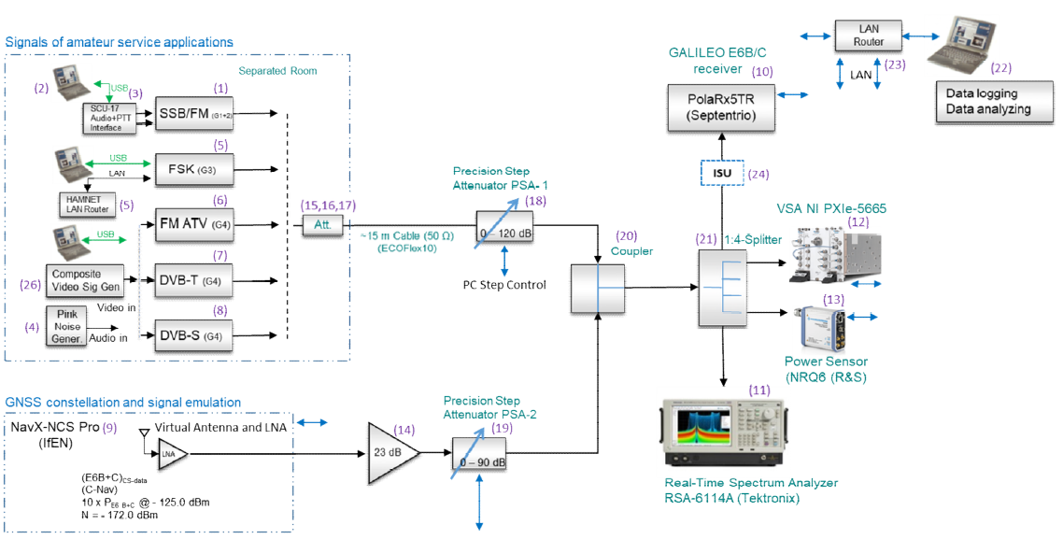
The scenario is as follows: the GNSS signal path is levelled in such a way that a C/N0 at the receiver's output of about 45 dBHz is achieved. The power and noise levels within the signal chain are measured. Changes to the levels in the GNSS signal path were only done via the corresponding step attenuator (noise level in that chain is dominated by the GNSS simulator and the line driver amplifier (device number 14) to maintain a constant C/No at the RF domain.
For each amateur signal, the full level at the lowest setting of the step attenuator in the amateur path (device number 18) was measured. Afterwards, the interfering level was set via the step attenuator only. This keeps the relation of the signal and the generated noise and unwanted emissions (spurious resp. out of Band domain) for any power level fed to the victim receiver. Device number 15 to 17 was applied to limit the max. power offered to the precision step attenuator.
The measurement procedure was as follows: the receiver was allowed to settle with the wanted signal active only. Then, a strong level from the unwanted signal was applied to enforce a strong dip in the C/No at the receiver; the interferer was disabled again for a few seconds (allowing the receiver to settle again) and finally the interferer was slowly ramped up in power. During the testing time, the C/No-values were logged, synchronized with the attenuator settings in the interfering signal path.
For any major type of radio amateur signal, a test case investigating the worst case conditions was performed, where the amateur radio signal was placed on the E6-centre frequency (as long as long as the device allowed that setting). Furthermore, frequency offsets as low as possible (according to the IARU-bandplan) were introduced.

A2.2 Measurement evaluation
Each test case produced files originally created by the receiver's internal measurement feature that were exported to a RINEX file. An evaluation tool transforms the C/No vs. time information of the PSA steps into a representation of C/No vs. the absolute power values at the input of an 0 dBi GNSS-antenna.
The mapping from the receiver input to the input of a 0 dBi antenna is as follows:
Given the noise level $N_{{BW}_{Noise}}$ in the E6-signal’s system bandwidth $BW_{Noise}$ of 40.92 MHz and an assumed noise figure of the active receive antenna ${\left(NF_{Ant}\right)}_{dB}$ of 2 dB, the gain of the antenna ${\left(G_{Ant}\right)}_{dB}$ can be derived from the thermal noise level (-174 dBm/Hz). This gain is also applied to the amateur radio signal level, resulting in the level at the input of a 0 dBi antenna.
#(1)

The evaluations also include a modelled result curve according to the equation of [10, p. 556], where the interference resistance factor Q has been chosen in such a way to smooth the model’s result close to the measured values.
#(2)

A2.3 Test cases and measurement results
There is a huge variety of radio amateur applications as indicated in this section 7. For that, a pre-selection process categorised the emissions into four Groups, representing the diversity of all potential RF emissions:
G1: signal bandwidth < 1 kHz (Morse, SSB voice);
G2: signal bandwidth up to 15 kHz (FM voice);
G3: signal bandwidth up to 200 kHz (high speed data)
G4: signal bandwidth 1 … 16 MHz (Amateur TV)

A2.3.1 Test case overview
The test cases were chosen in such a way that all available amateur signal groups were used. The carrier frequencies were varied to measure at least (if possible) the interfering signal on the Galileo E6-centre frequency (worst case scenario) and with the least possible frequency separation from the E6-centre frequency, if IARU's band plan for Region 1 is respected (bound to the transmitter's available channel selection options).
The following Table 4 gives an overview of all measurements performed. Within the table, the columns have the following meaning:
Group: indicates the group of emission classes the interfering signal belongs to.
Topic: contains a short description of the test’s settings.
Interfering freq.: centre frequency of the amateur radio signal, in MHz
Offset from E6-centre: the difference between the amateur radio signal’s centre frequency and the E6-centre frequency, in MHz.
Level type (amateur radio): refers to the detector/measurement type used in measuring the RFI at 0 dB attenuation.

Table 1
Measurements Galileo E6 vs. amateur radio - overview of test cases performed
Group | Topic | Interfering freq./MHz | Offset  from E6-centre/MHz | Level type  (amateur radio)
1 | Morse, IARU band plan | 1296.20 | 17.45 | PEP
1 | Morse, centre frequency | 1278.75 | 0.00 | PEP
1 | SSB voice, IARU band plan | 1296.20 | 17.45 | PEP
1 | SSB voice, centre frequency | 1278.75 | 0.00 | PEP
1 | SSB voice, centre frequency, ISU mitigation | 1278.75 | 0.00 | PEP
2 | FM voice, IARU band plan | 1297.50 | 18.75 | PEP
2 | FM voice, centre frequency | 1278.75 | 0.00 | PEP
2 | FM voice, centre frequency, AIM+ filter | 1278.75 | 0.00 | PEP
2 | FM voice, centre frequecy, ISU mitigation | 1278.75 | 0.00 | PEP
3 | FSK 128 kbps, IARU band plan | 1299.21 | 20.46 | PEP
3 | FSK 128 kbps, centre frequency | 1278.75 | 0.00 | PEP
3 | FSK 128 kbps, centre frequency ISU mitigation | 1278.75 | 0.00 | PEP
4 | FM-ATV, IARU band plan | 1280.00 | 1.25 | PEP
4 | DVB-T 1, IARU band plan | 1288.00 | 9.25 | RMS
4 | DVB-T 1 MHz, centre frequency | 1278.75 | 0.00 | RMS
4 | DVB-T 1 MHz, centre frequency, ISU mitigation | 1278.75 | 0.00 | RMS
4 | DVB-T 4 MHz, IARU frequency | 1286.00 | 7.25 | RMS
4 | DVB-T 4 MHz, centre frequency | 1278.75 | 0.00 | RMS
4 | DVB-S 6 MHz, centre frequency | 1278.75 | 0.00 | RMS
4 | DVB-T 1 MHz, frequency sweep | various | various | RMS
4 | DVB-T 1 MHz, center frequency | 1278.75 | 0.00 | RMS

A2.3.2 Measurement results
The following sections detail the result for the individual test case, sorted by the interfering signal. In any section, two plots are given - one that shows the total test result over the whole RFI power tested and a second one that concentrates on the CN0 degradation in a range of -5 … 0 dBHz relative to the 45 dBHz baseline.
The figures relate the CN0 as reported by the victim receiver to the interfering power supplied by the output of an 0 dBi antenna. . The relationship between the power supplied to the receiver's input port and the equivalent power at the reference antenna is given above.

A2.3.2.1 Morse (Test Cases G1-03, G1-04)
The results for the Morse signal are shown in Figure 25. The C/No plots indicate strong variations. It can be seen that a frequency separation of 17.45 MHz from the centre frequency relaxes the C/No-degradation by approx. 30 dB. Figure 26 shows the changes in C/No relative to a reference of 45 dBHz.
Table 5 shows that at a C/No degradation of 1dB, an additional e.g. 0.5 dB increases the margin of interference power by 2 dB.
Figure 2
Processed results summary for Morse signal
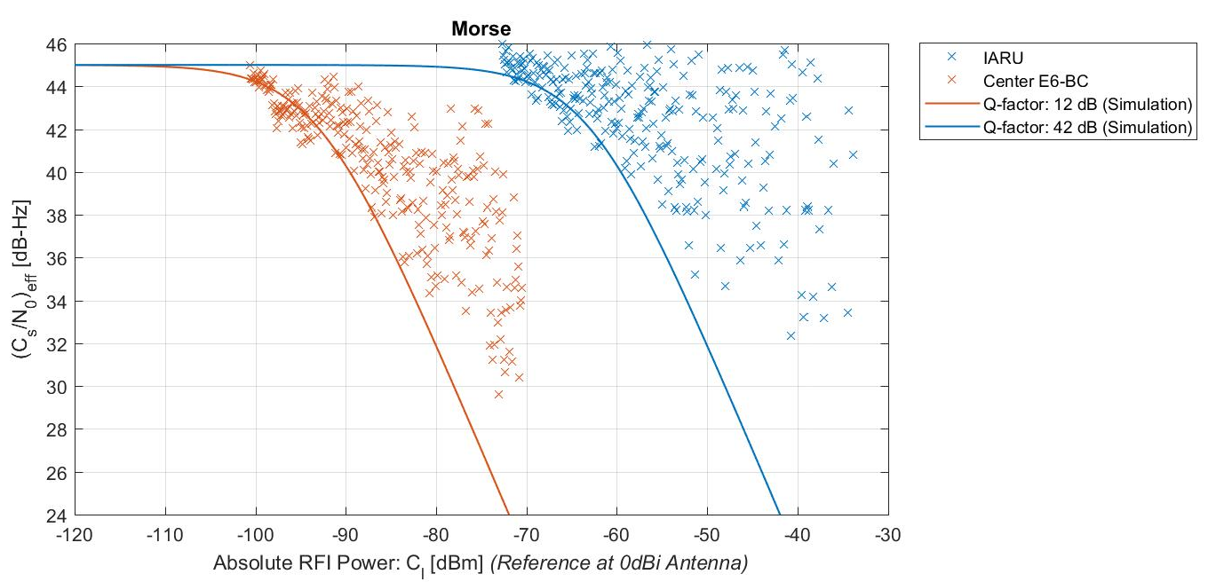
Figure 3
Result summary showing C/N0 changes relative to 45 dBHz for Morse signal

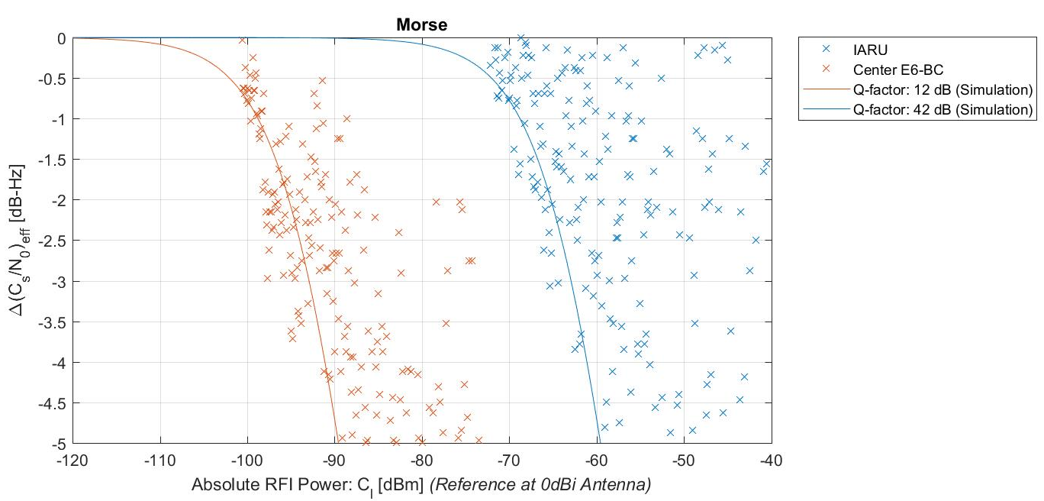
Table 2
Key values for Morse signal: maximum signal power at 0 dBi antenna to certain C/N0 degradation allowance
ΔC/N0 | Morse  1 296.20 MHz | Morse  1 278.75 MHz | Morse  1 278.75 MHz with ISU
-1 dB | -68,8 dBm | -98,8 dBm | N/A
-1,5 dB | -66,7 dBm | -96,8 dBm | N/A
-5 dB | -59,6 dBm | -89,6 dBm | N/A
Q-factor | 42 dB | 12 dB | N/A

A2.3.2.2 SSB voice (Test Cases G1-07, G1-08, G1-13)
The results for the SSB voice signal are shown in Figure 27. Figure 28 shows the changes in C/N0 relative to a reference of 45 dBHz. It can be seen that a frequency separation of 17.45 MHz away from the centre frequency relaxes the C/N0-degradation by almost approx. 40 dB.
If the ISU is not inserted in the centre frequency scenario, the C/N0 degrades fast.
Table 6 shows that at a C/N0 degradation of 1dB, an additional e.g. 0.5 dB increases the margin of interference power by 2dB.
Furthermore, the significant improvement by the ISU is clearly visible: although the ISU has to mitigate the RFI on Galileo’s E6 centre frequency, it allows even more interference signal power than in the offset frequency case where the ISU is not inserted. Considering that the SSB signal has a certain similarity to the Morse signal (both are narrow band, “pulse-type” emissions; but the amplitude variations in the signal envelope differ) the ISU produces a significant improvement on RFI mitigation.
Figure 4
Result summary for SSB voice signal

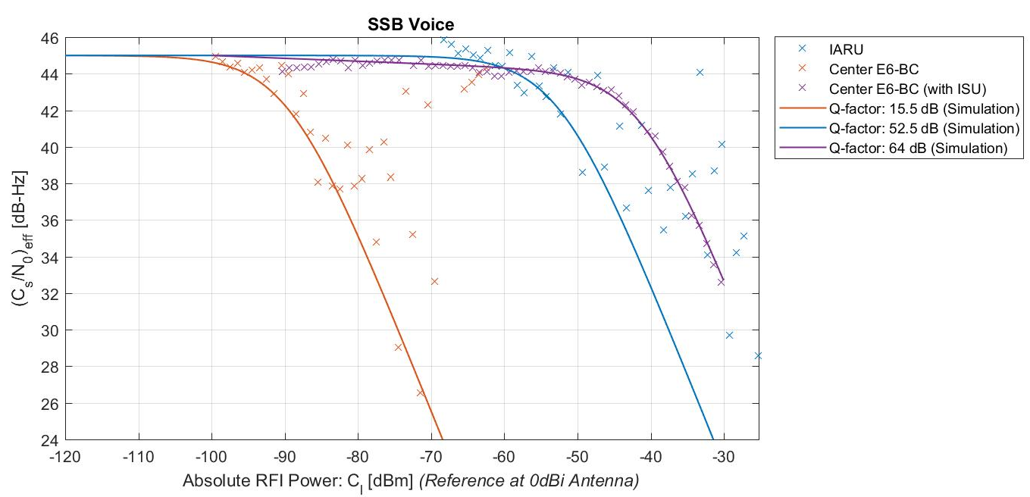
Figure 5
Result summary showing C/N0 changes relative to 45 dBHz for SSB voice signal
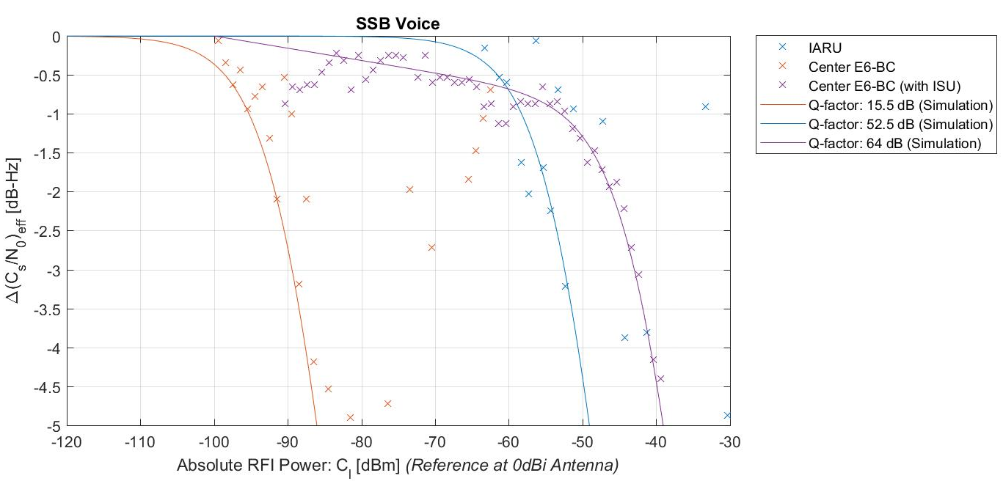
Table 3
Key values for SSB voice signal: maximum signal power at 0 dBi antenna to certain C/N0 degradation allowance
ΔC/N0 | SSB voice  1296.20 MHz | SSB voice  1278.75 MHz | SSB voice  1278.75 MHz with ISU
-1 dB | -58,3 dBm | -95,3 dBm | -53 dBm
-1,5 dB | -56,3 dBm | -93,3 dBm | -48,6 dBm
-5 dB | -49,1 dBm | -86,1 dBm | -39,1 dBm
Q-factor | 52,5 dB | 15,5 dB | 64 dB

A2.3.2.3 FM voice (Test Cases G2-03, G2-04, G2-04 w/WB, G2-05)
The results for the FM voice signal are shown in Figure 29. Figure 30 shows the changes in C/N0 relative to a reference of 45 dBHz. Apparently, a frequency offset of 18.75 MHz from the centre frequency improves the C/N0-degradation by more than 40 dB.
No difference can be seen between the receiver operated with and without the receiver’s built-in AIM+ mitigation.
The ISU compensates the interfering signal on the centre frequency at least as good as a frequency offset from the centre frequency, i.e. operates on frequencies in accordance with IARU Band plan.
Table 7 shows that at a C/N0 degradation of 1 dB, an additional e.g. 0.5 dB increases the margin of interference power by 2 dB.
Figure 6
Result summary for FM voice signal
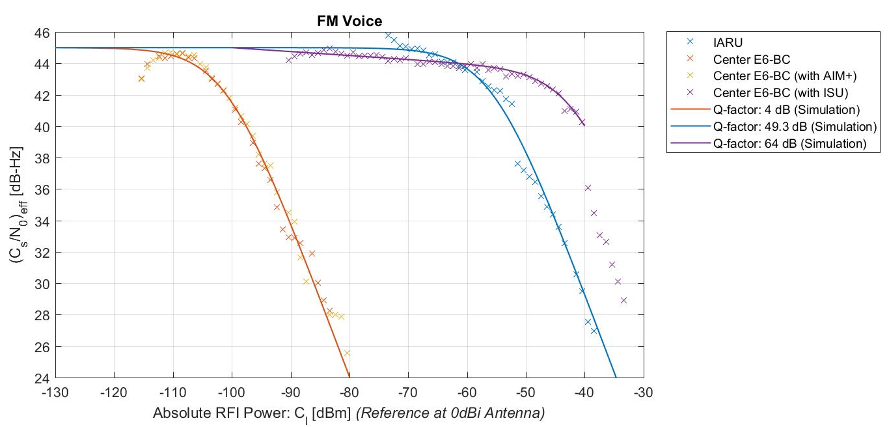
Figure 7
Result summary showing C/N0 changes relative to 45 dBHz for FM voice signal

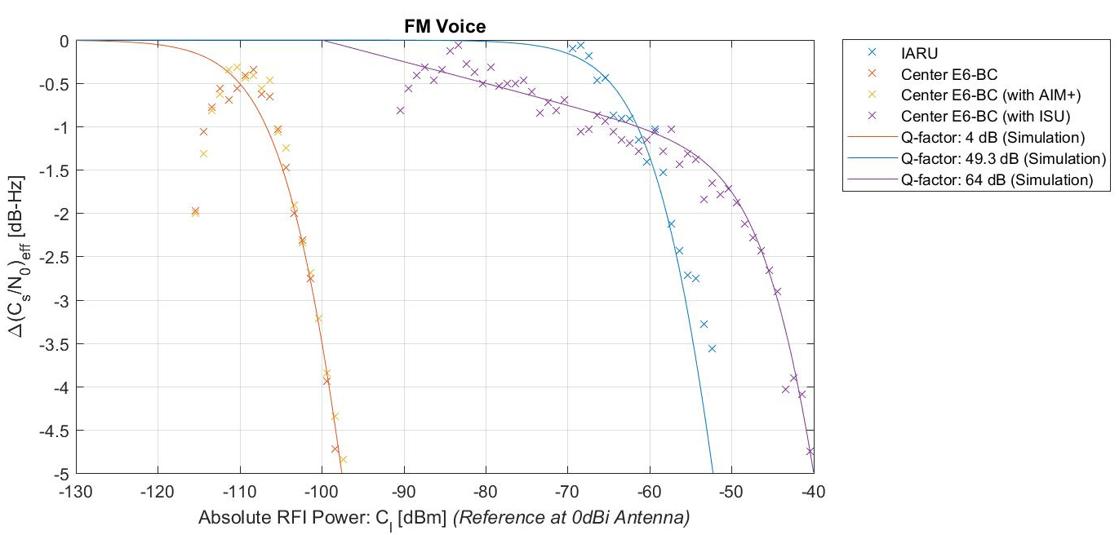
Table 4
Key values for FM voice signal: maximum signal power at 0 dBi antenna to certain C/N0 degradation allowance
ΔC/N0 | FM voice  1297.50 MHz | FM voice  1278.75 MHz | FM voice  1278.75 MHz with ISU
-1 dB | -61,5 dBm | -106,8 dBm | -61,5 dBm
-1,5 dB | -59,5 dBm | -104,8 dBm | -52,2 dBm
-5 dB | -52,2 dBm | -97,6 dBm | -40 dBm
Q-factor | 49,3 dB | 4 dB | 64 dB

A2.3.2.4 FSK 128 kbps (Test Cases G3-03, G3-04, G3-06)
The results for the FSK are shown in Figure 31. Figure 32 shows the changes in C/N0 relative to a reference of 45 dBHz. A frequency separation of 20.46 MHz off the centre frequency improves the C/N0-degradation by more than 50 dB. The ISU compensates the interfering signal on the centre frequency almost as good as compared to the signal operated with an offset from the centre frequency.
Table 8 shows that at a C/N0 degradation of 1dB, an additional e.g. 0.5 dB increases the margin of interference power by 2 dB.
Figure 8
Result summary for FSK signal
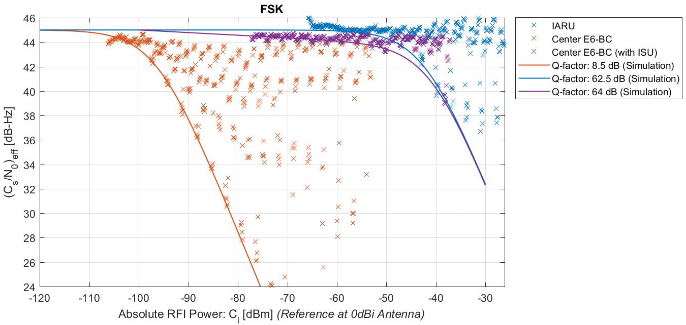
Figure 9
Result summary showing C/N0 changes relative to 45 dBHz for FSK signal
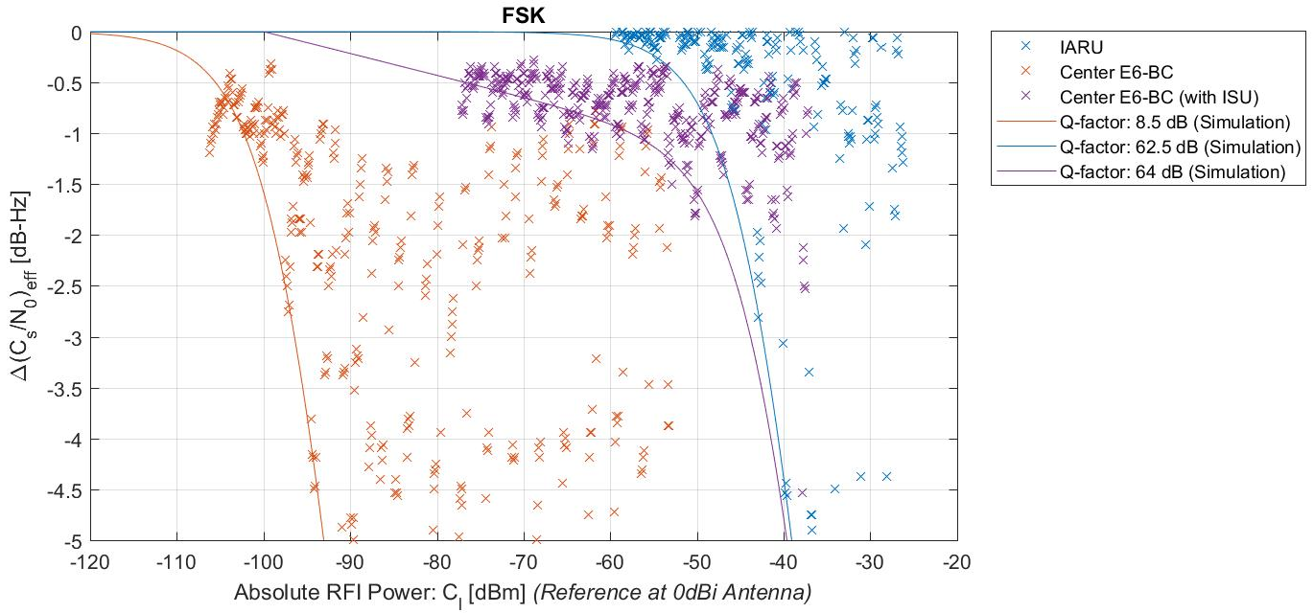
Table 5
Key values for FSK signal: maximum signal power at 0 dBi antenna to certain C/N0 degradation allowance
ΔC/N0 | FSK  1299.21 MHz | FSK  1278.75 MHz | FSK  1278.75 MHz with ISU
-1 dB | -48,3 dBm | -102,3 dBm | -57,7 dBm
-1,5 dB | -46,3 dBm | -100,3 dBm | -50,7 dBm
-5 dB | -39,1 dBm | -93,1 dBm | -39,7 dBm
Q-factor | 62,5 dB | 8,5 dB | 64 dB

A2.3.2.5 FM-ATV (Test Case G4-01)
The result for the FM-ATV signal is shown in Figure 33. Figure 34 shows the changes in C/N0 relative to a reference of 45 dBHz. The signal was offset by 1.25 MHz from the centre frequency. It can be seen that the modulation’s constant envelope prevents strong fluctuations in the C/N0-indication.
Table 9 shows that at a C/N0 degradation of 1dB, an additional e.g. 0.5 dB increases the margin of interference power by 2dB.
Further tests regarding frequency offsets were not performed: according to the IARU Band plan, this type of signal normally uses that frequency.
Figure 10
Result summary for FM-ATV
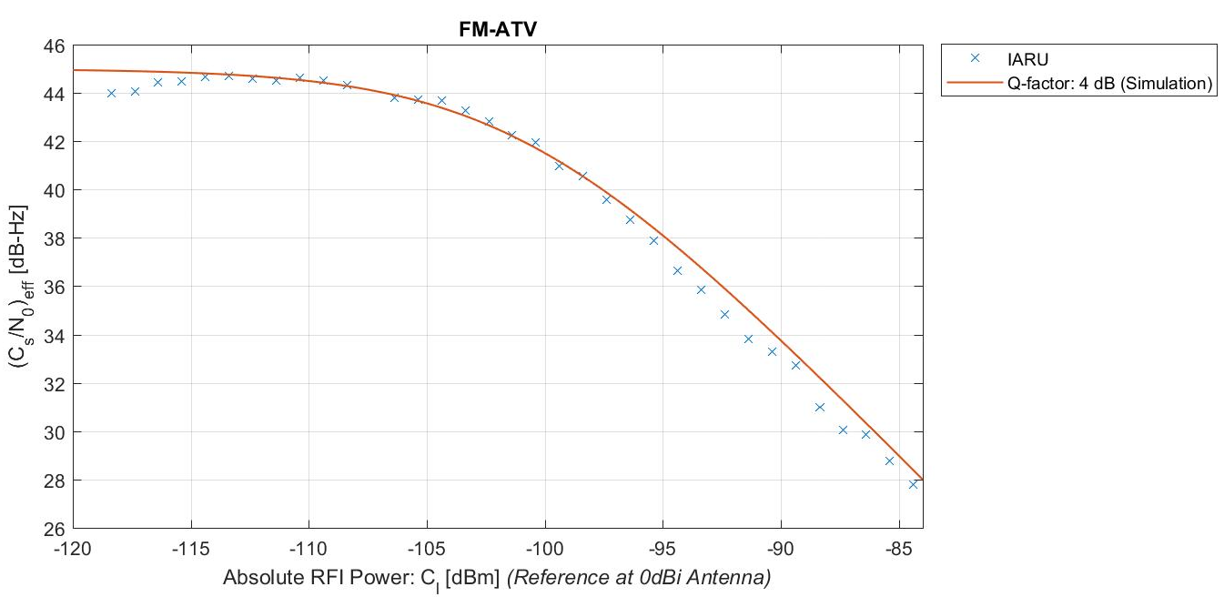
Figure 11
Result summary showing C/N0 changes relative to 45 dBHz for FM-ATV
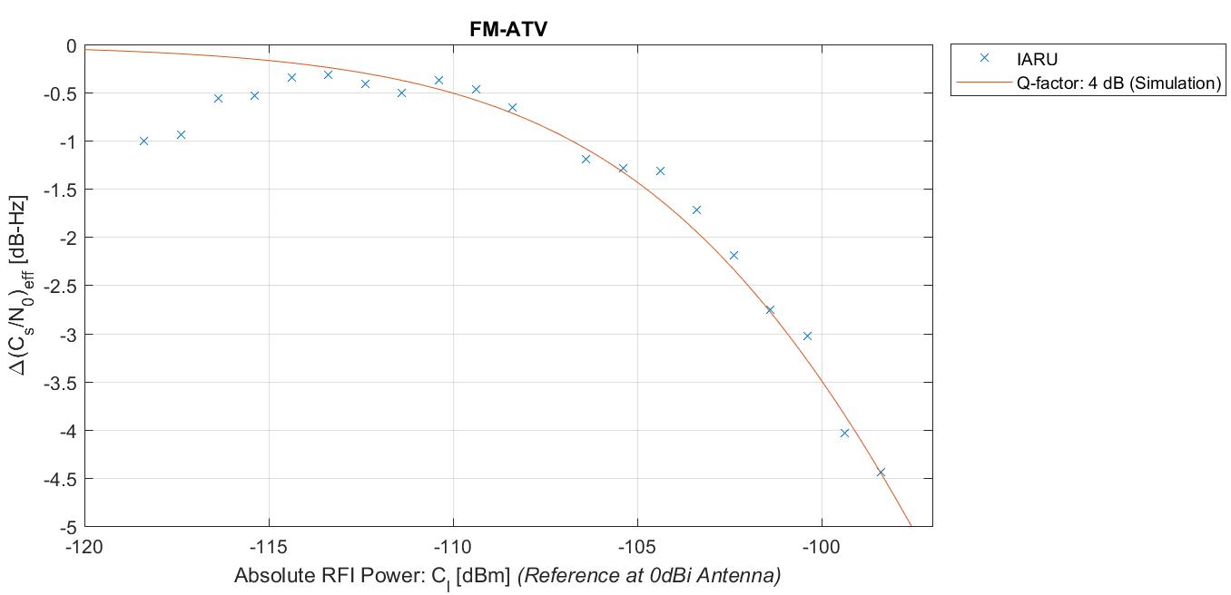
Table 6
Key values for FM ATV signal: maximum signal power at 0 dBi antenna to certain C/N0 degradation allowance
ΔC/N0 | FM ATV  1280.00 MHz | FM ATV  1278.75 MHz | FM ATV  1278.75 MHz with ISU
-1 dB | -106,8 dBm | N/A | N/A
-1,5 dB | -104,8 dBm | N/A | N/A
-5 dB | -97,6 dBm | N/A | N/A
Q-factor | 4 dB | N/A | N/A

A2.3.2.6 DVB-T ATV with 1MHz bandwidth (Test Cases G4-05, G4-06, G4-06x)
The result for the DVB-T ATV-signal with a bandwidth of 1 MHz is shown in Figure 35. Figure 36 shows the changes in C/N0 relative to a reference of 45 dBHz. In the offset case, the interfering signal’s centre frequency was shifted 9.25 MHz away from E6 centre frequency. No strong fluctuations can be seen as compared to e.g. the Morse or FSK signal.
The result shows that a frequency offset relaxes the interference situation. Furthermore, the ISU performs differently as compared to the narrow band emissions, albeit for the power levels tested it still prevents the C/N0 to degrade to less than 38 dBHz. This might be due to the following reasons:
The current state of the ISU’s development is to perform best on small band signals.
The ISU removes those parts of the spectrum that have been identified as an unwanted signal. The wider the removed spectrum, the more power of the Galileo spectrum is also removed. Because of this removal, an inherent drop of C/N0 by approx. 2 dB occurs. This can be seen at RFI level of approx. -71 dBm.
The bump in the ISU-curve is due it's detection threshold: as long as the incoming signal is not rated as interference, the ISU does nothing at all.
Table 10 shows that at a C/N0 degradation of 1dB, an additional e.g. 0.5 dB increases the margin of interference power by 2 dB.
Figure 12
Result summary for DVB-T ATV, 1 MHz bandwidth
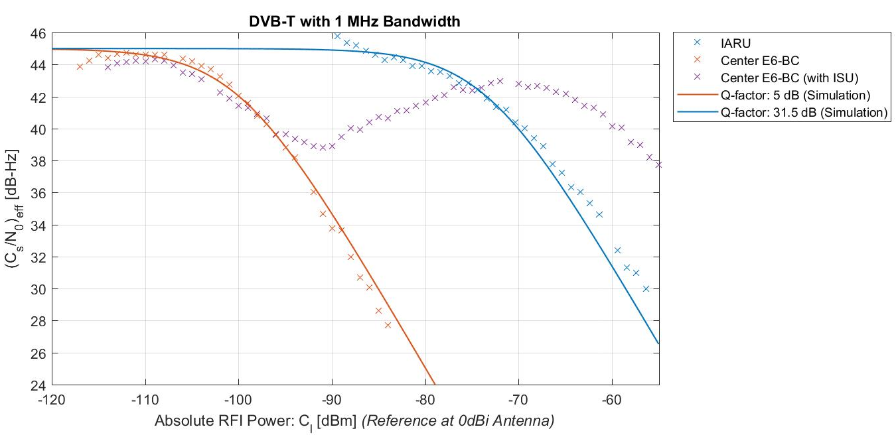
Figure 13
Result summary showing C/N0 changes relative to 45 dBHz for DVB-T ATV, 1 MHz bandwidth
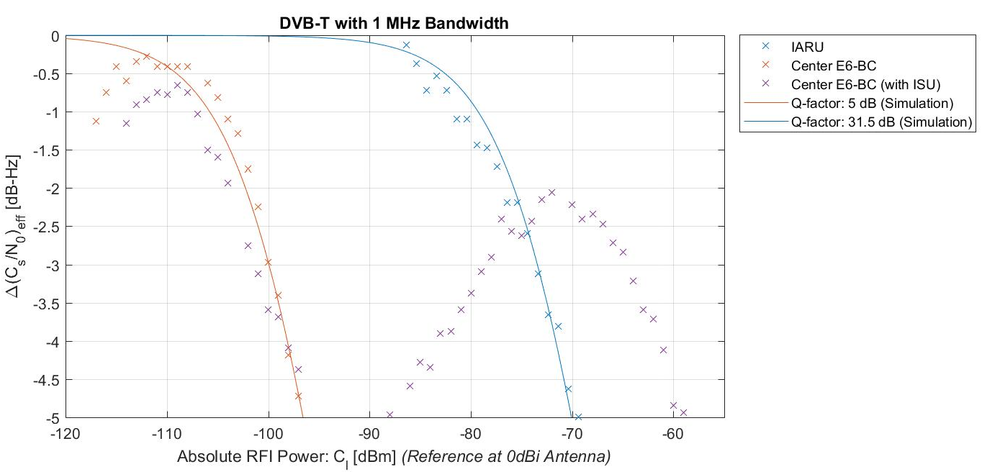
Table 7
Key values for DVB-T ATV signal (1 MHz bandwidth): maximum signal power at 0 dBi antenna to certain C/N0 degradation allowance
ΔC/N0 | DVB-T ATV  1 MHz  1280.00 MHz | DVB-T ATV  1 MHz  1278.75 MHz | DVB-T ATV,  1 MHz,  1278.75 MHz with ISU
-1 dB | -79,3 dBm | -105,8 dBm | -
-1,5 dB | -77,3 dBm | -103,8 dBm | -
-5 dB | -70,1 dBm | -96,6 dBm | -
Q-factor | -31,5 dB | 5 dB | -

A2.3.2.7 DVB-T ATV with 1MHz bandwidth, variable centre frequency offsets (Test Case G4-18)
In addition, further tests were performed to study the influence of various carrier frequencies for the DVB-T signal. For that, the DVB-T signal level was kept constant, while the frequency was shifted through a portion of GALILEO’s signal spectrum. The result is shown in Figure 37 with absolute C/N0 values on the left Figure and C/N0-values relative to the value at Δf=15 MHz in the right Figure).
The figure can be read as follows: the GALILEO signal is the more affected the closer the interferer is to its centre frequency. This complies largely with results reported in the previous sections. The spectral zero at the offset -5 MHz is not as vulnerable as the centre frequency, but more sensitive than the zero at -15 MHz.
The test was not extended to the positive frequency offset range, since the spectra of the E6B/C signals involved are symmetric around their centre frequency. This general finding is considered sufficient for an initial estimation of the RF compatibility situation.
Figure 14
Influence of different centre frequencies of the DVB-T signal. Left hand side: absolute C/N0 values; right hand side: C/N0-values relative to the values at the frequency offset of -15 MHz

A2.3.2.7 DVB-T ATV with 4 MHz bandwidth (Test Cases G4-09, G4-10);
DVB-S ATV with 6 MHz bandwidth (Test Case G4-14)
The results for the DVB-T ATV-signal with a bandwidth of 4 MHz and the DVB-S signal (bandwidth: 6 MHz) are shown in Figure 38. Figure 39 shows the changes in C/N0 relative to a reference of 45 dBHz. In the offset case (DVB-T only), the RFI carrier frequency was shifted 7.25 MHz away from E6 centre frequency. No strong fluctuations can be seen as compared to e.g. the Morse or FSK signal. When comparing this Figure to the 1 MHz DVB-T case, one has to remember that the offset in this case is smaller (interferer is closer to the centre frequency) and the signal is wider (interferer’s power is spread wider across the spectrum, reaching even further to the centre frequency). Apart from that, the DVB-S signal has a constant envelope, in contrast to the DVB-T OFDM signal.
The result shows that a frequency offset relaxes the interference situation, but far less than in the 1 MHz bandwidth case.
Table 11 shows that at a C/N0 degradation of 1dB, an additional e.g. 0.5 dB increases the margin of interference power by 2dB.
Figure 15
Result summary for DVB-T ATV, 4 MHz bandwidth and DVB-S ATV, 6 MHz bandwidth
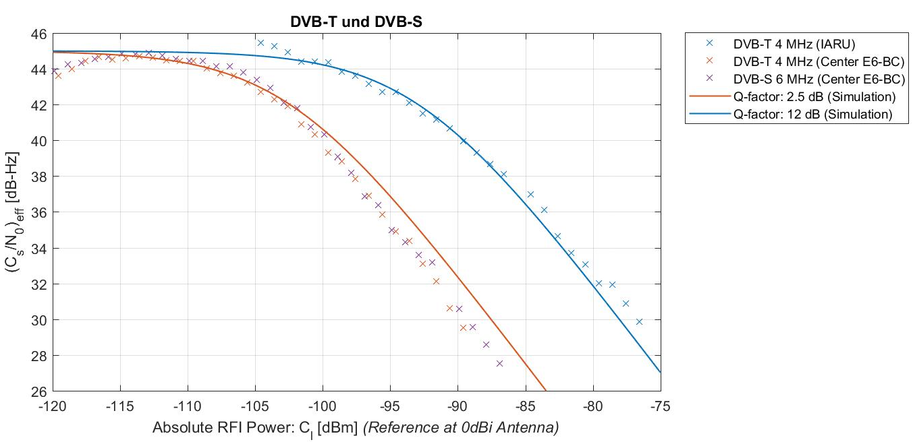
Figure 16
Result summary showing C/N0 changes relative to 45 dBHz for DVB-T ATV, 4 MHz bandwidth and DVB-S ATV, 6 MHz bandwidth
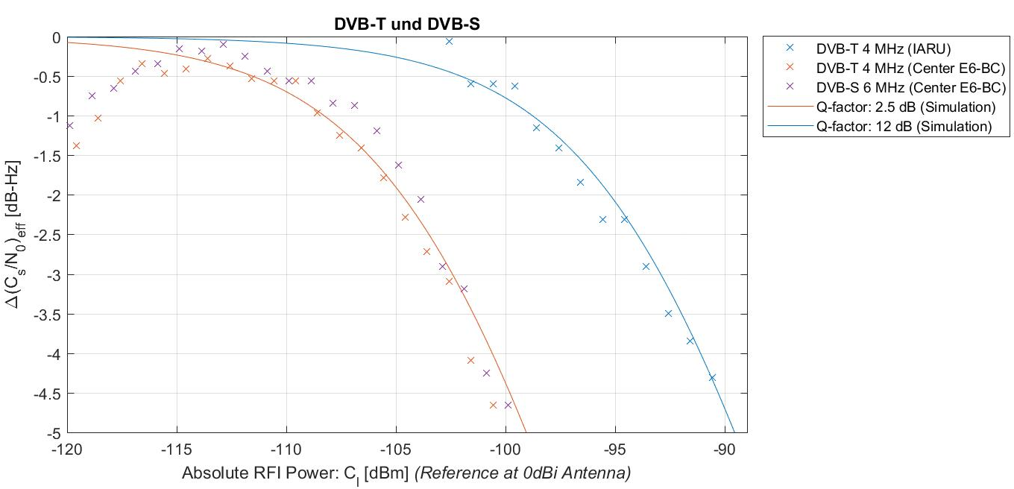

Table 8
Key values for DVB-T ATV signal (4 MHz Bandwidth) and DVB-S (6 MHz Bandwidth): maximum signal power at 0 dBi antenna to certain C/N0 degradation allowance
ΔC/N0 | DVB-T ATV  4 MHz  1286.00 MHz | DVB-T ATV  4 MHz, and  DVB-S 6 MHz  1278.75 MHz | DVB-T ATV,  4 MHz,and DVB-S 6 MHz  1278.75 MHz with ISU
-1 dB | -98,8 dBm | -108,3 dBm | N/A
-1,5 dB | -96,8 dBm | -106,3 dBm | N/A
-5 dB | -89,6 dBm | -99,1 dBm | N/A
Q-factor | 12 dB | 2,5 dB | N/A

A2.3.2.8 Test for independence of initial C/N0 (Group G4-20)
To study if the initial set C/N0-ratio has an influence on the measurement result, the following test was performed: the level of the simulated GALILEO signals was set in such a way that every two satellite signals had the same power. The noise power level remained unchanged with respect to the previous measurements.
Then, the DVB-T signal with 1 MHz bandwidth was applied as RFI on the E6 centre frequency. The test sequence started again (setting a trigger point, returning to the initial signal power level and gradually increasing the RFI power). The result is shown in Figure 40 below.
It can be seen that all lines run in parallel to each other. This means that the absolute value of the initial C/N0 has no influence on C/N0 degradation as long as that C/N0 is far above the receiver's sensitivity to capture the wanted signal.
Figure 17
C/N0 vs. time with different GALILEO signal power levels, interfered by a DVB-T signal (1 MHz bandwidth, E6 centre frequency)
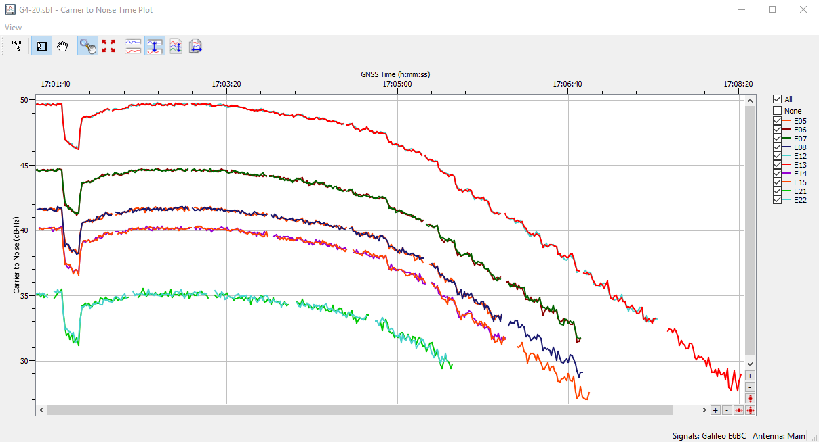

A2.4 Summary
Measurements were performed to study the effects on the post-correlation C/N0 when different amateur radio signals arrive at a 0 dBi antenna of a GALILEO E6B/C DS SS CDMA receiver. Many different signal types and frequency combinations were investigated to cover not only worst case, but also typical situations.
The tests performed considered all signals that are usually emitted in the amateur service on frequencies in accordance with the IARU band plan as well as on the E6 centre frequency.
The findings can be summarised as follows:
The worst case occurs when an interfering signal is applied on the E6 centre frequency
Vice versa: frequency separation from centre frequency yields significantly higher tolerable levels for the interfering signal (e.g. when using frequencies i.a.w. the IARU Band plan)
A non-constant envelope of the interfering signal leads to high scattering of the receivers observed C/N0.
Although DVB-T OFDM-signals also employ a non-constant envelope, they are fast enough to avoid such fluctuations and have apparently less dynamic amplitude changes than, for example, an on/off-keyed narrow band signal such as used in Morse telegraphy
The used Interference Suppression Unit (ISU) can significantly reduce the impact of interfering signals, particularly for narrowband signals (B < 150 kHz).
Even if the ISU’s performance was not tested against the Morse signal, one can expect a similar behaviour as seen in the e.g. SSB signal case.
Against the wider amateur TV signals, the used ISU did not lead to a strong receiver immunity.
The wider the signal to be supressed (i.e. filtered), the more energy is taken from the E6 signal. This reduction of the RF signal's CN0 leads to a worse CN0 at the receiver's output.
It is to be noted that the used receiver’s input filter is smaller than specified (30 MHz instead of 40.92 MHz). Nonetheless, the RF level measurements respect the full channel bandwidth.
______________

